Windows Server / Microsoft Project 1

Windows Objective 1

Enable Project Server 2019 on the Windows server - https://learn.microsoft.com/en-us/project/install-and-configure-project-server-2016 1

Open the SharePoint Management Shell as Administrator. 1

Verify that you have the following memberships: 2

securityadmin fixed server role on the SQL Server instance. 2

db_owner fixed database role on all databases that are to be updated 5

Local Administrators group on the server on which you are running the PowerShell cmdlets 6

From the PowerShell command prompt, type the following syntax to enable Project Server Subscription Edition, 2019, or 2016 9

Error 9

Check for a Project Server Service Application 12

To register a managed account 14

Using SharePoint, create a new ‘Project Server Service Application’ 14

To create a Project Server service application 14

Specify the Project Services application name and ‘create a new application pool’ 17

Spelling Error 18

Error 19

Configure a web-based ‘Network Upgrade’ project (‘SharePoint Task List’ recommended. 20

Share your Project site with your WinUsers 22

In your ‘Network Upgrade’ project, create and assign at least one task with a deadline for WinUser1 23

In your ‘Network Upgrade’ project, create and assign at least one task with a deadline for WinUser2 24

Log on to the server as WinUser 1 and VERIFY ‘WinUser1’ has access to the shared Project and assigned tasks through the Project web console 25

Log on to the server as WinUser 2 and VERIFY ‘WinUser2’ has access to the shared Project and assigned tasks through the Project web console 26

Windows Summary: 27

Linux 27

Linux Objective : 27

Install all prerequisite software for the package chosen 27

Install and configure your chosen Project software platform 29

Configure a web-based ‘Network Upgrade’ project in your chosen project management Solution 30

Change Password 30

Create users named ‘LinuxUser1’ and ‘LinuxUser2’ in your chosen project management solution and set their passwords to ‘Password2’ 30

Change the password rule to 8 characters 30

Assign Passwords to each 30

Share your Project site with your LinuxUsers 30

Assign ‘LinuxUser1’ and ‘LinuxUser2’ to work on the project. 30

In your ‘Network Upgrade’ project, create and assign at least one task with a deadline for LinuxUser1 30

In your ‘Network Upgrade’ project, create and assign at least one task with a deadline for LinuxUser2 30

Log on to your Linux virtual machine as LinuxUser1 and verify ‘LinuxUser1’ 30

Log on to your Linux virtual machine as LinuxUser2 and verify ‘LinuxUser2’ 30

REBOOT YOUR SERVER and repeat the previous two steps of verifying LinuxUser Access 30

Linux Summary: 30

# Windows Server / Microsoft Project

Windows Objective: To configure Microsoft Project Server 2019 on a Windows Server environment integrated with SharePoint, in order to manage a Network Upgrade project. Objectives include enabling Project Services, creating a web-accessible project site, assigning tasks to WinUser1 and WinUser2, and verifying user access and task visibility.

## Enable Project Server 2019 on the Windows server - https://learn.microsoft.com/en-us/project/install-and-configure-project-server-2016

### Open the SharePoint Management Shell as Administrator.

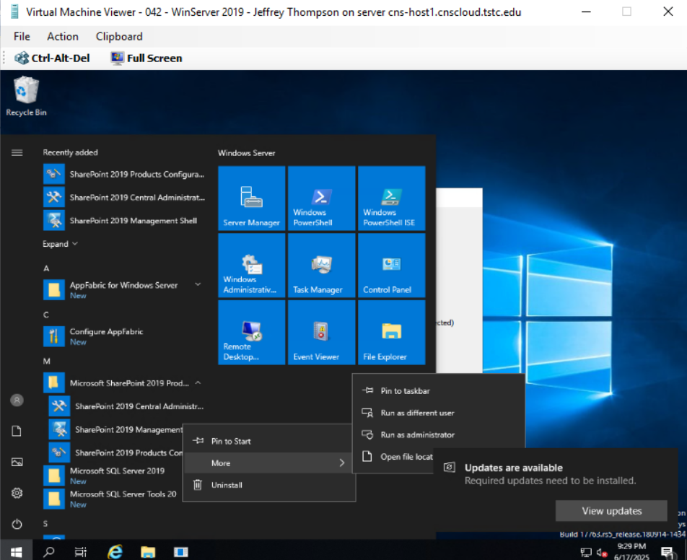

### Verify that you have the following memberships:

#### securityadmin fixed server role on the SQL Server instance.

Open SSMS and connect to the SQL Server

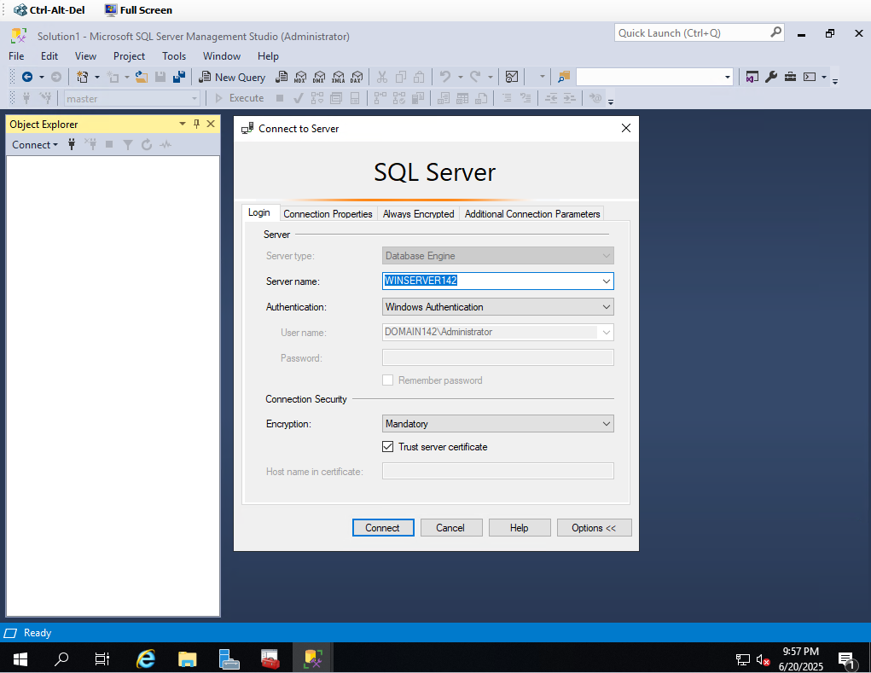

Security > Logins > Right-Click Admin Profile > Properties > Verify Server Roles

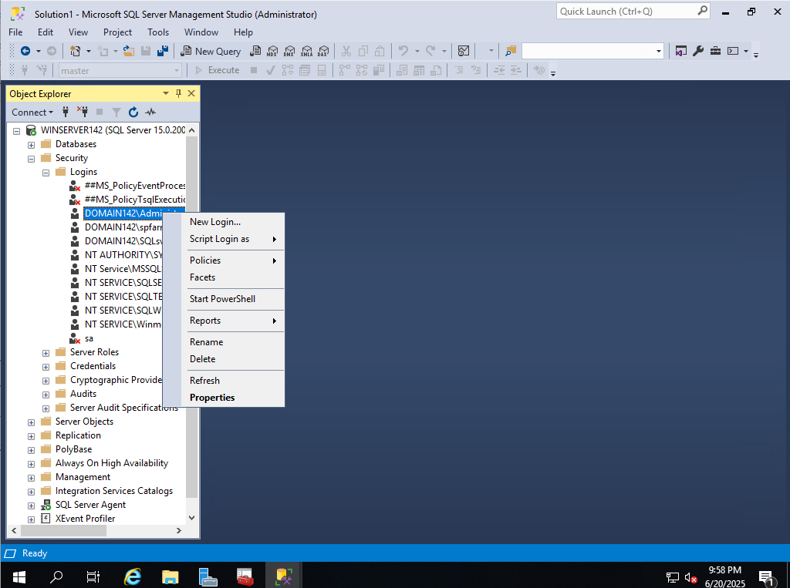

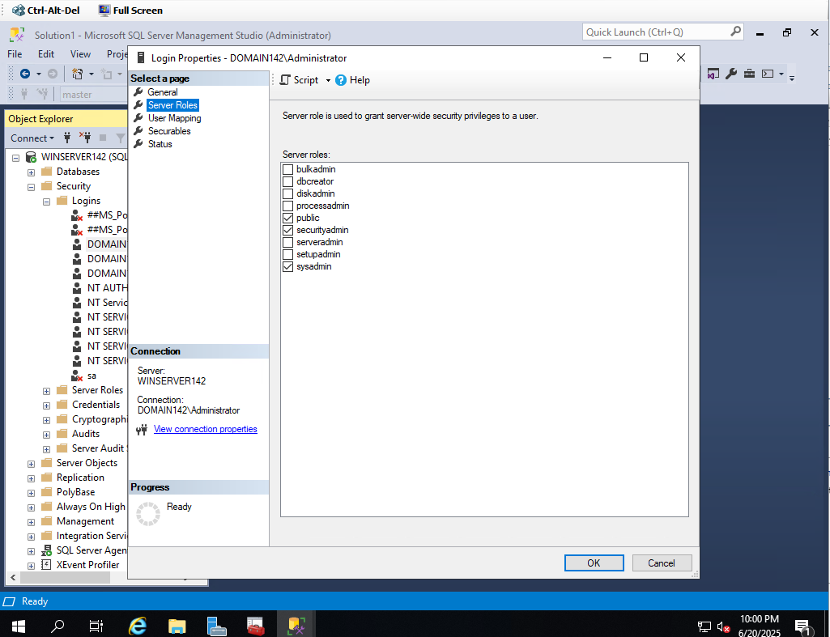

db_owner fixed database role on all databases that are to be updated.

Expand Databases > SharePoint_Config>Users> Right-Click DOMAIN142\spfarm >Properties

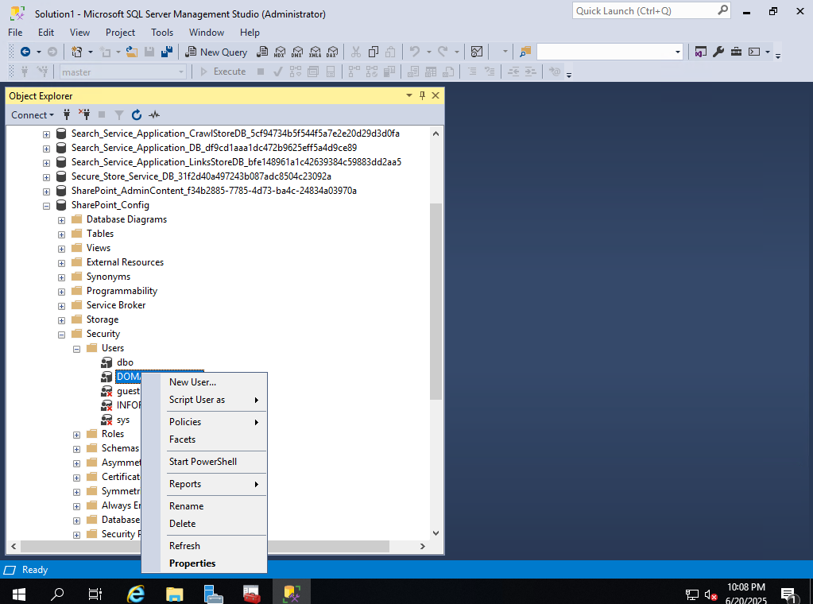

Select membership and verify db owner

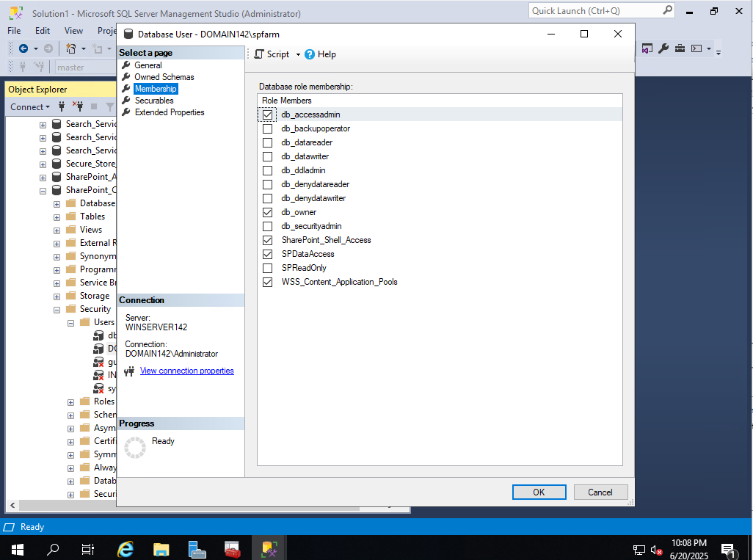

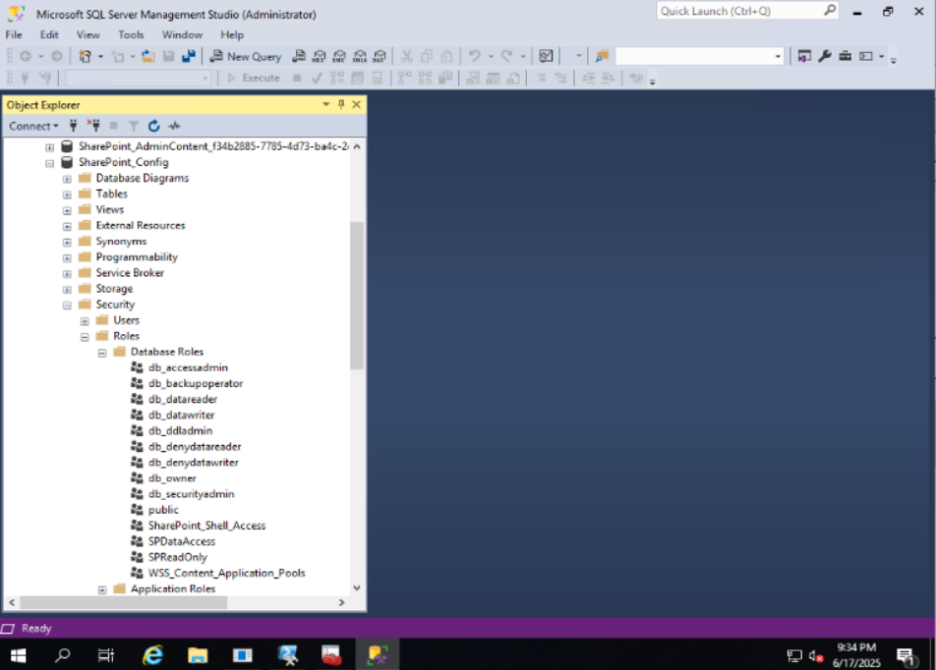

Local Administrators group on the server on which you are running the PowerShell cmdlets.

Control Panel > User Accounts > User Accounts

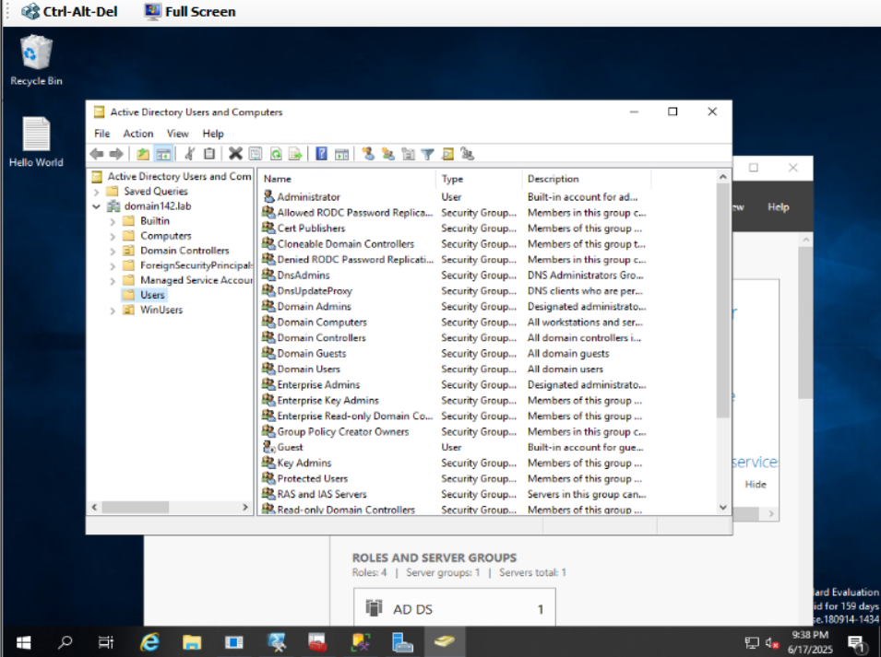

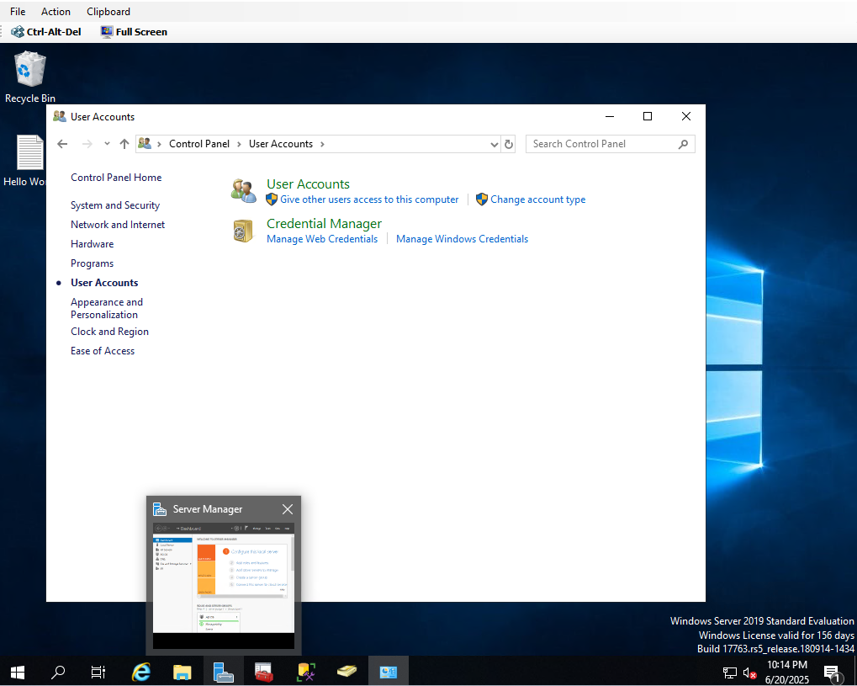

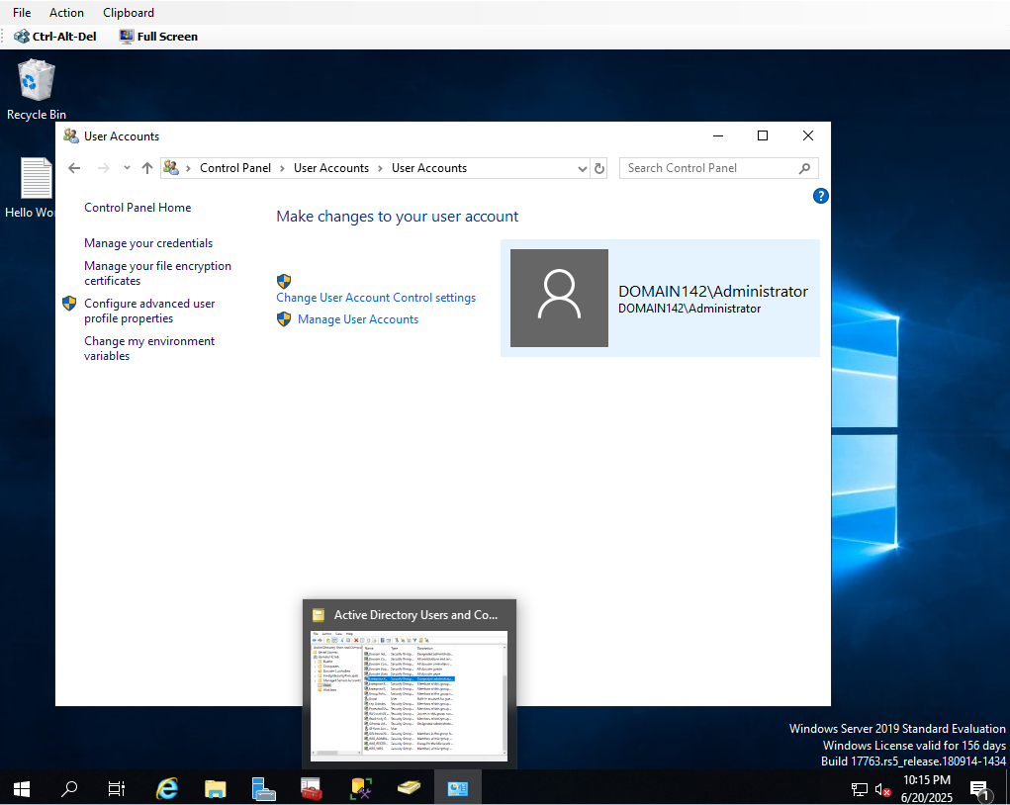

An administrator can use the [Add-SPShellAdmin](https://learn.microsoft.com/en-us/powershell/module/sharepoint-server/Add-SPShellAdmin) cmdlet to grant permissions to use Project Server cmdlets.

From the PowerShell command prompt, type the following syntax to enable Project Server Subscription Edition, 2019, or 2016:

Enable-ProjectServerLicense -Key <LicenseKey>

### **Error**

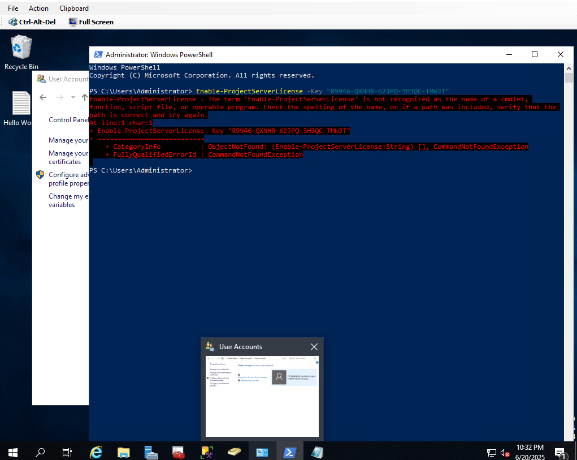

It needs to be run in the sharepoint management shell instead of power shell

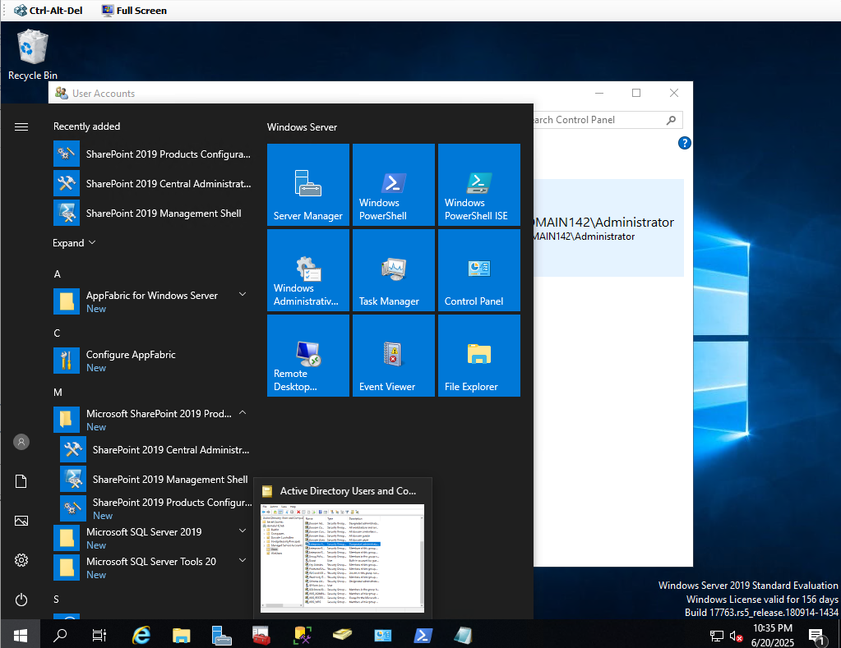

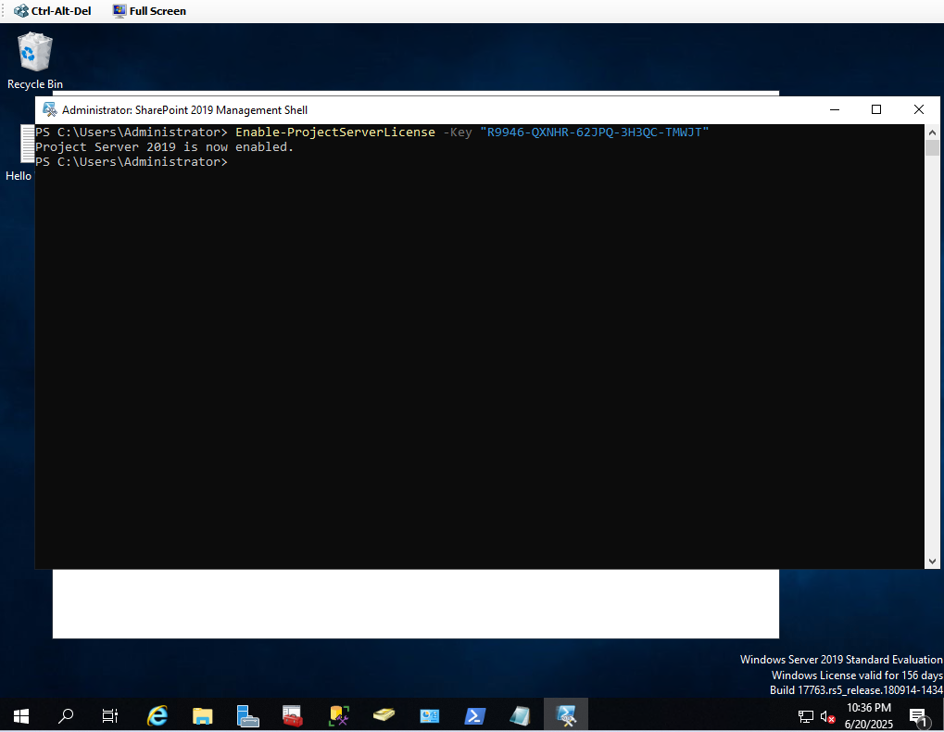

### Check for a Project Server Service Application

Project Server runs as a service application in SharePoint Server, so the first thing to do is check to see if you already have a Project Server Service Application configured.

In the SharePoint Central Administration website, under Application Management, click Manage service applications.

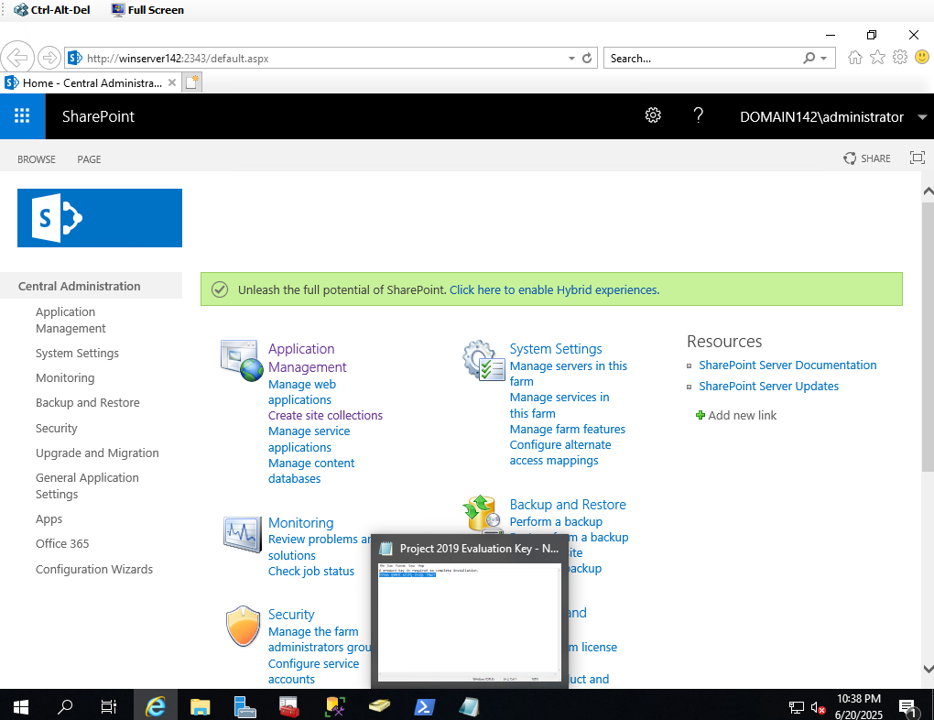

Check the service applications list for a Project Server Service Application.

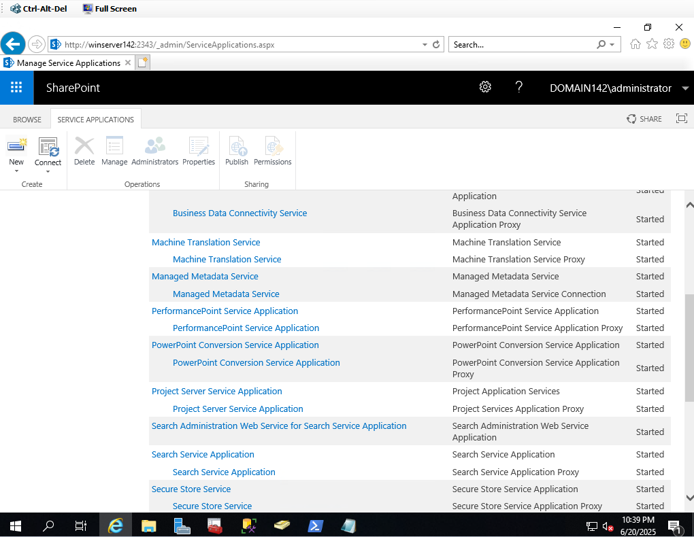

### To register a managed account

On the Central Administration home page, in the left navigation, click Security.

On the Security page, in the General Security section, click Configure managed accounts.

On the Managed Accounts page, click Register Managed Account.

Type the user name and password of the domain account that you are registering.

Optionally, select the Enable automatic password change check box if you want SharePoint Server to manage password changes for this account.

Click OK.

## Using SharePoint, create a new ‘Project Server Service Application’

### To create a Project Server service application

1. On the Central Administration home page, in the **Application Management** section, click **Manage service applications**.

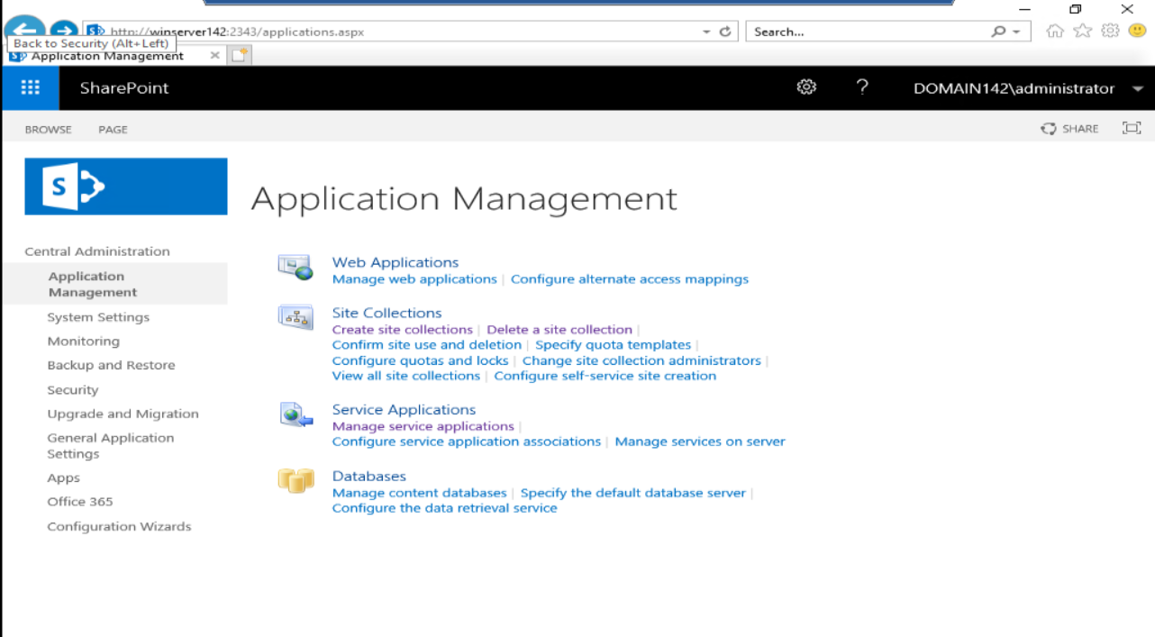

1. On the Manage Service Applications page, on the ribbon, click **New**, and then click **Project Server Service Application**.
2. 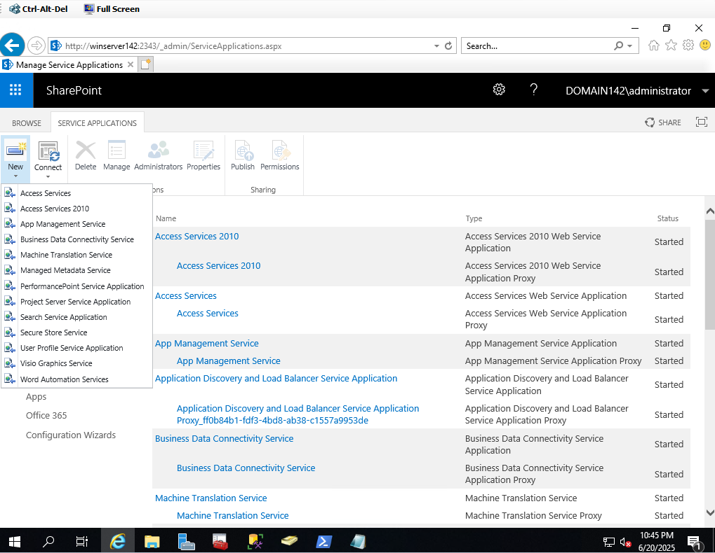
3. On the Create Project Web App service application page:
4. Type a name for the service application in the **Project Web App service application name** box.
5. In the **Application Pool** section, type the name of the application pool you want to create in the **Application pool name** box.

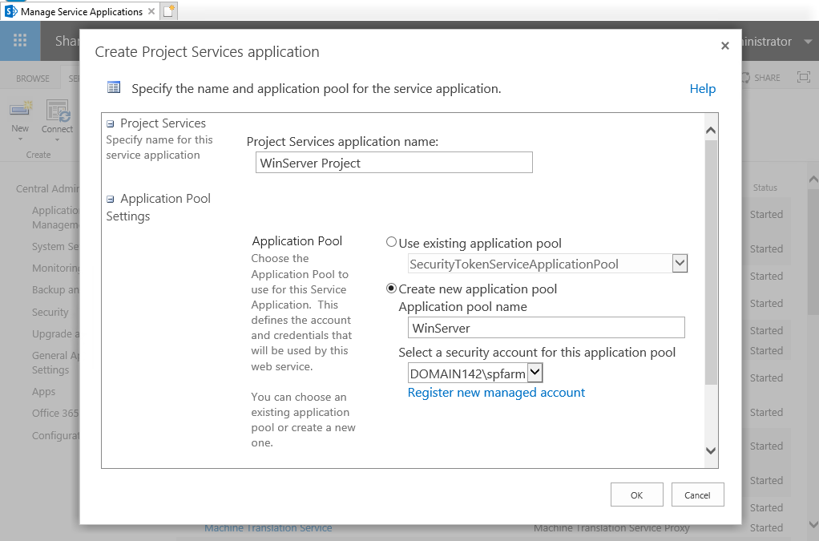

1. Select the **Configurable** option, and choose the managed account that you want to use to run the application pool.

The site has to be created and activated using powershell. <https://learn.microsoft.com/en-us/powershell/module/sharepoint-server/new-spsite?view=sharepoint-server-ps>

### Specify the Project Services application name and ‘create a new application pool’

New-SPSite -URL "http://winserver142/sites/pwa" -OwnerAlias "DOMAIN142\administrator" -Language 1033 -Template "pwa#0"

Error

e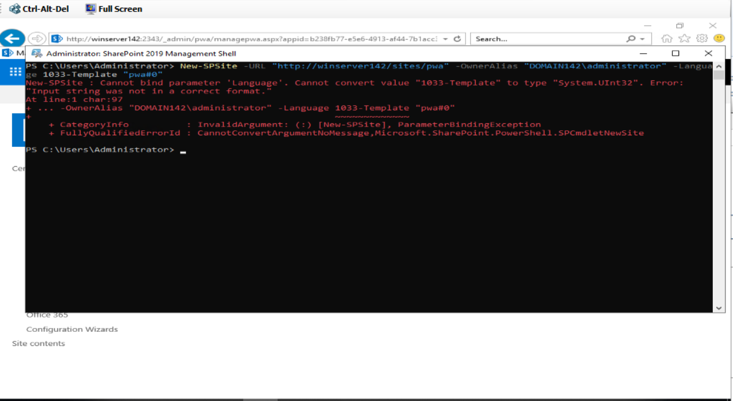

Need to change the command

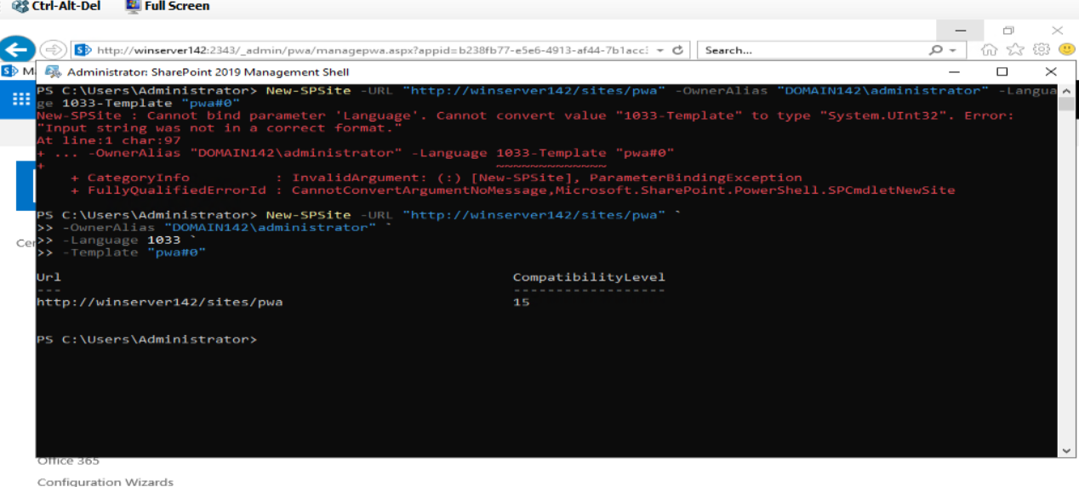

b. Make note of and document the custom created URL * / \*\***(http://winserver142/sites/pwa)**

c. Using the URL from the previous step, activate the ‘New-SPSite’ and enable the

‘SPFeature'

Enable-SPFeature -Identity ProjectWebApp -Url "http://winserver142/sites/pwa"

E

### **Spelling Error**

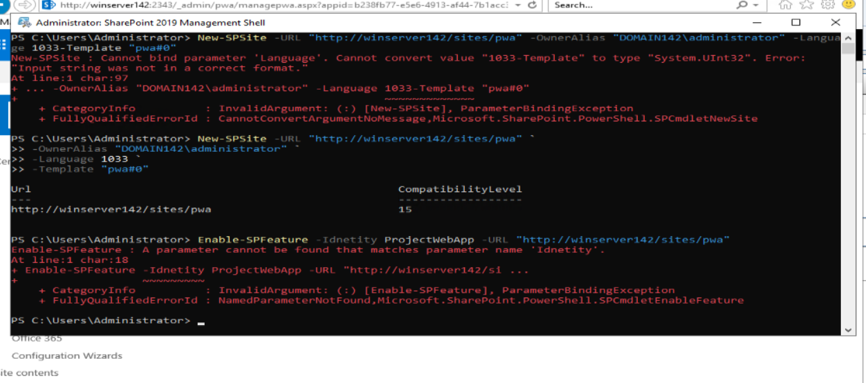

**Error**-Just used command from video activity.

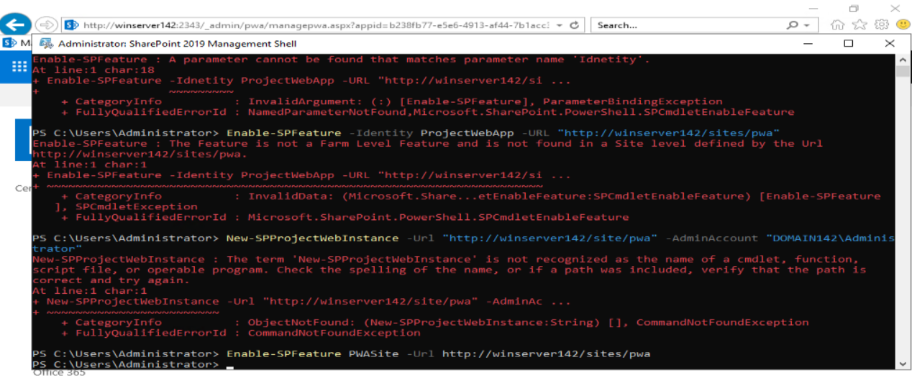

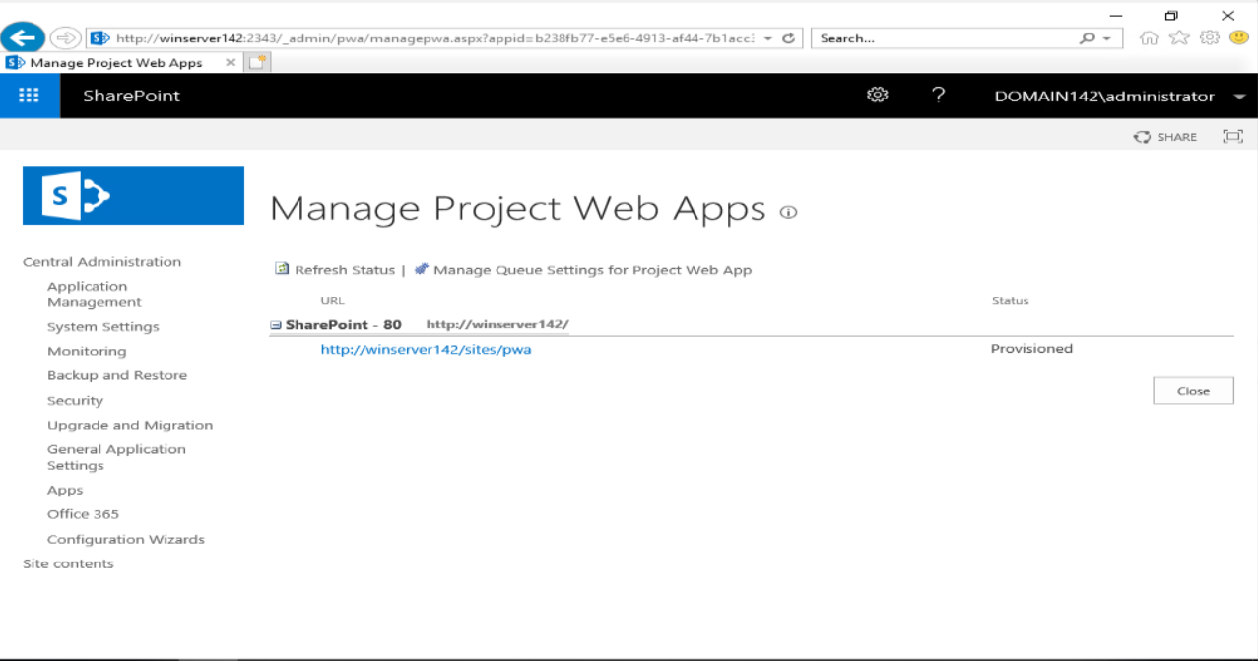

Once MS Project is enabled and configured, your icons should be Green (instead of the SharePoint blue) on the URL

identified in the previous step.

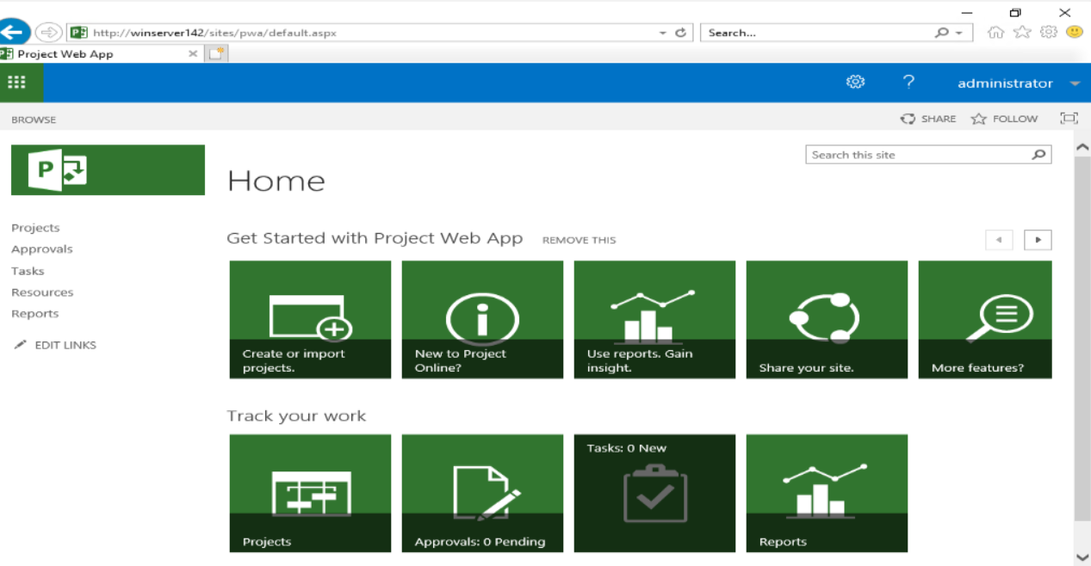

Configure a web-based ‘Network Upgrade’ project (‘SharePoint Task List’ recommended.

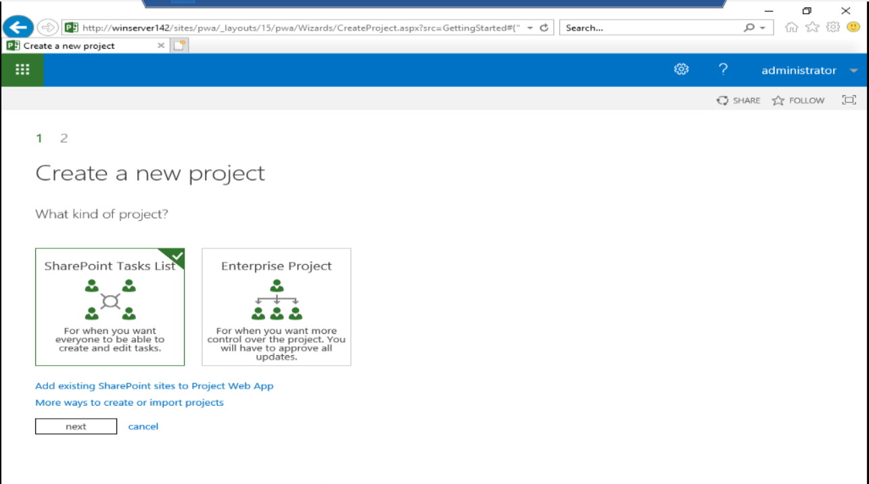

When naming your new project, keep in mind that the name will be appended to the URL you registered in a previous step. Using a space in the name may have a negative impact on the true project URL. Pay attention to and document the URL identified at the “Find it at...” area directly below the “Give it a name” field when creating your

new project.

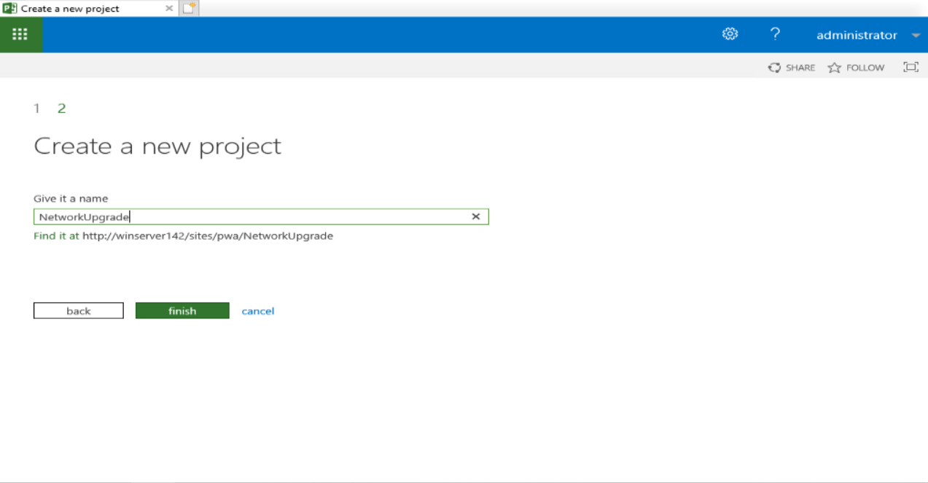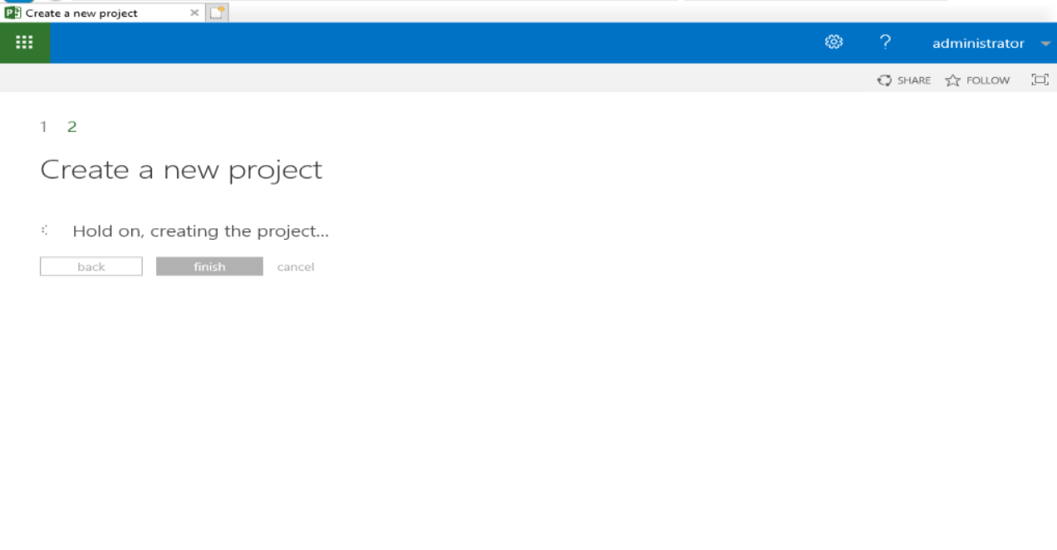

### Share your Project site with your WinUsers

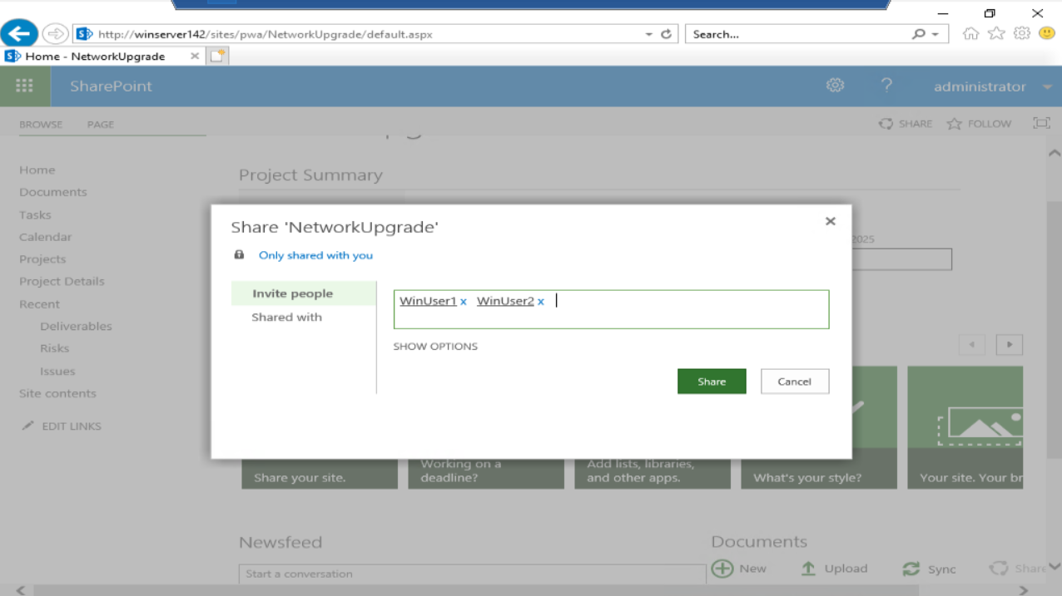

### In your ‘Network Upgrade’ project, create and assign at least one task with a deadline for WinUser1

\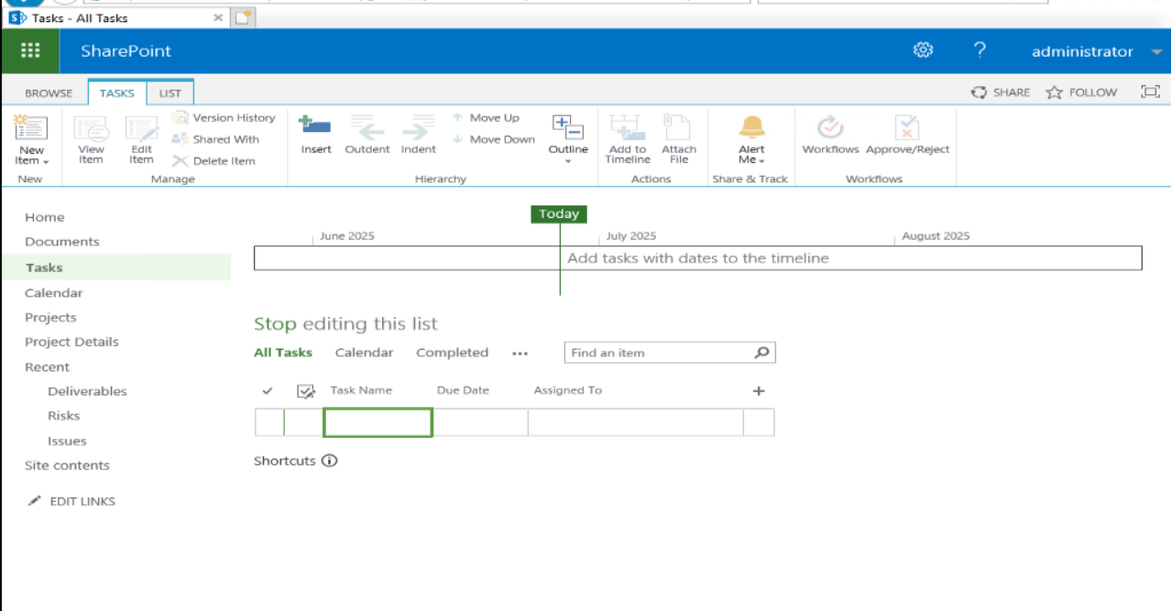

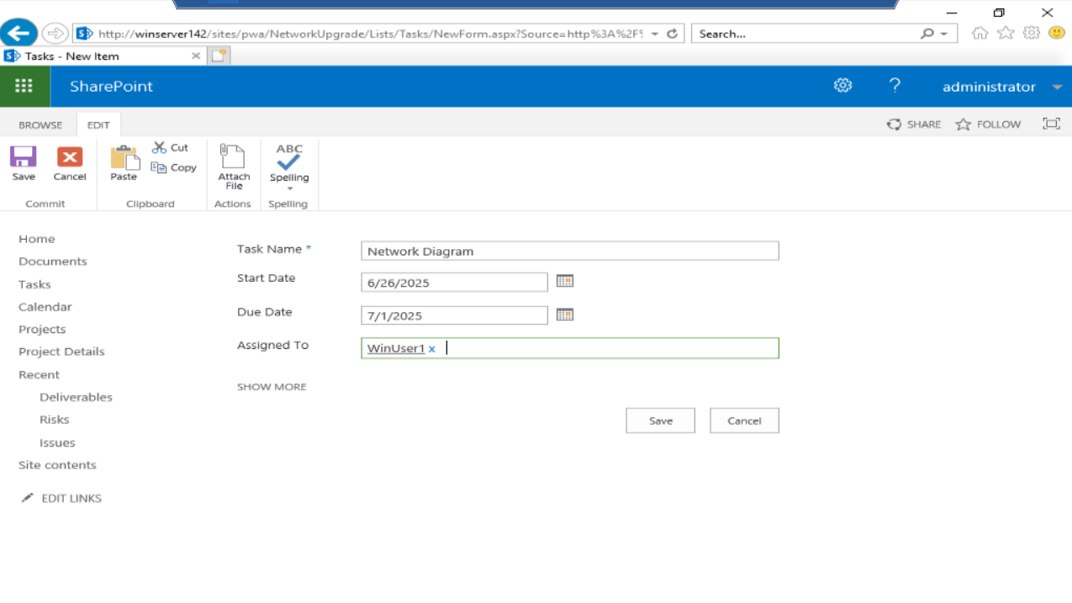

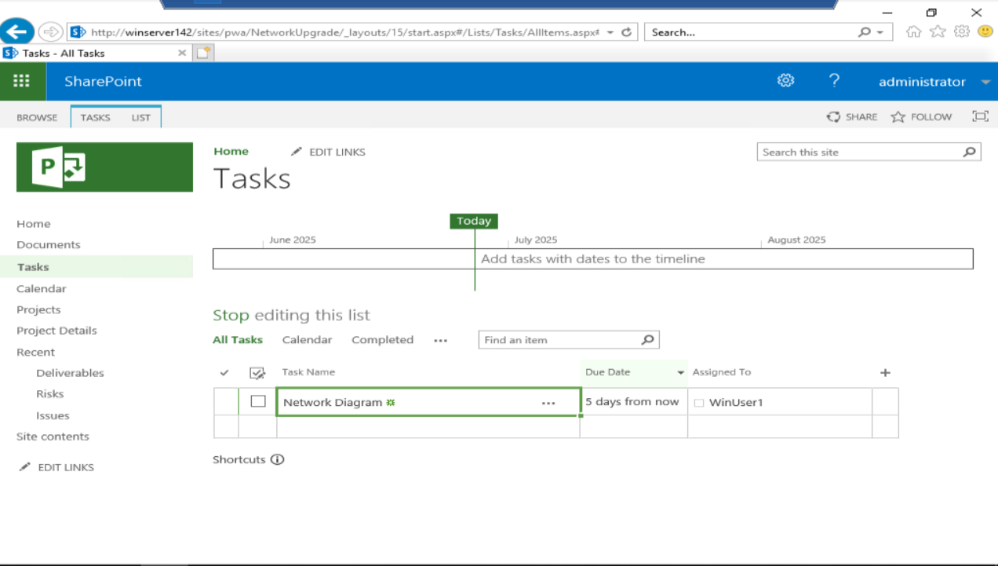

### In your ‘Network Upgrade’ project, create and assign at least one task with a deadline for WinUser2

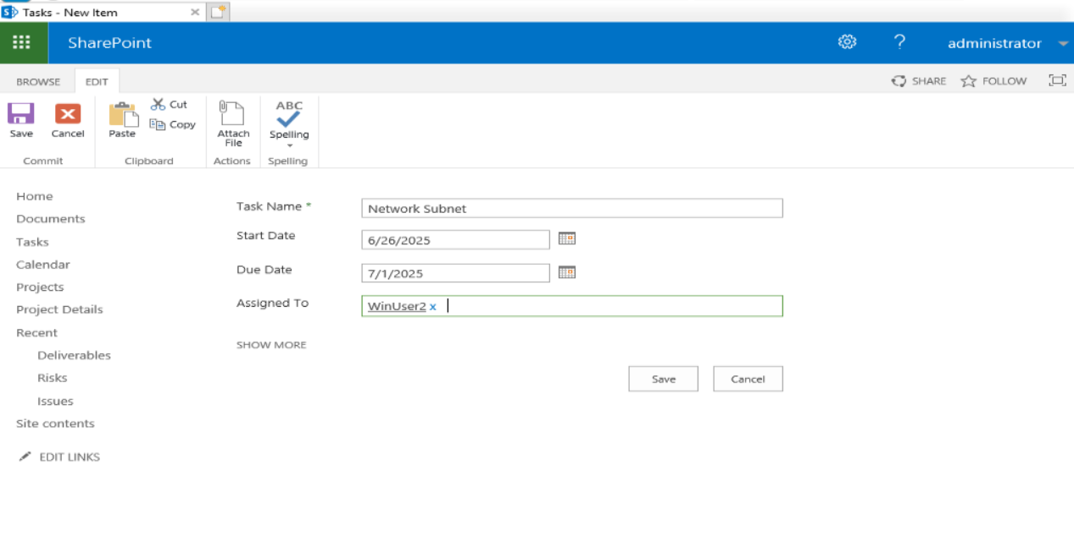

### Log on to the server as WinUser 1 and VERIFY ‘WinUser1’ has access to the shared Project and assigned tasks through the Project web console

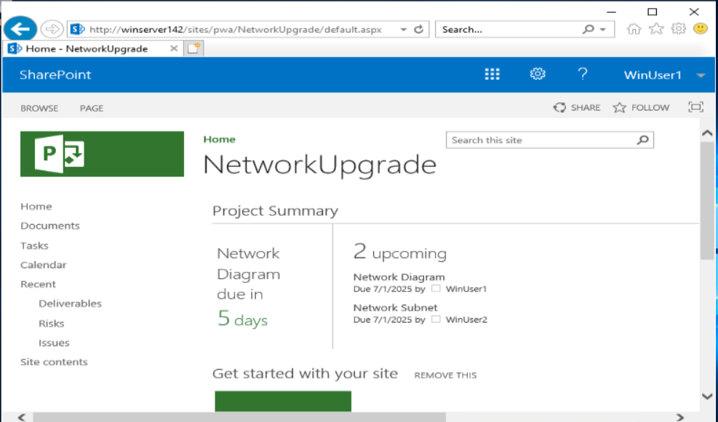

Bookmark the Project page for WinUser1

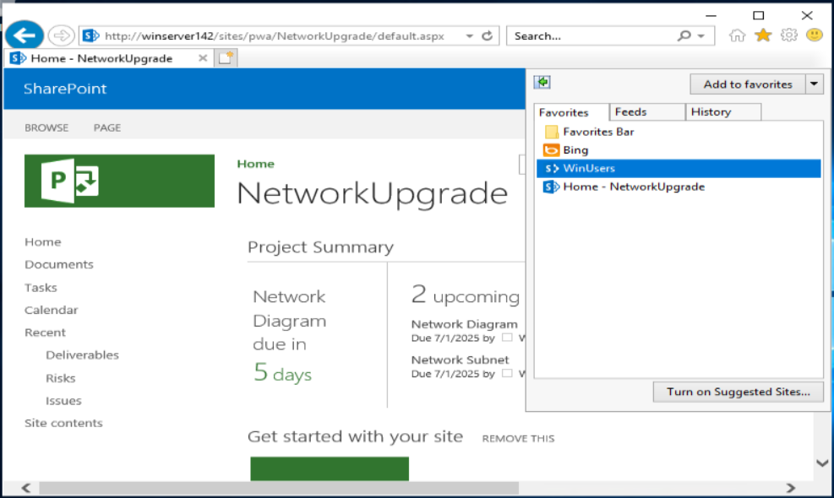

### Log on to the server as WinUser 2 and VERIFY ‘WinUser2’ has access to the shared Project and assigned tasks through the Project web console

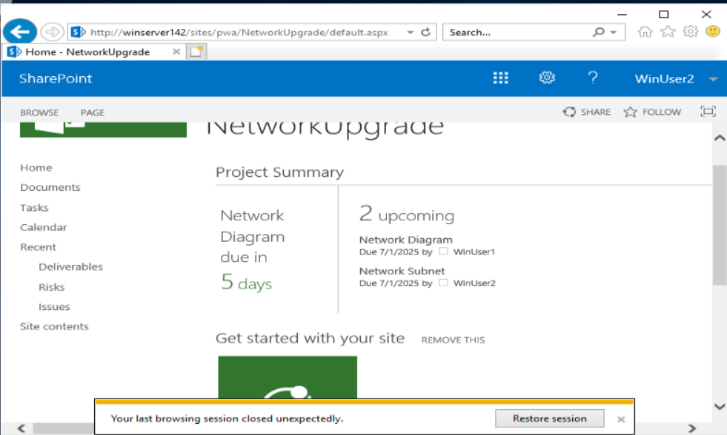

Bookmark the Project page for WinUser2

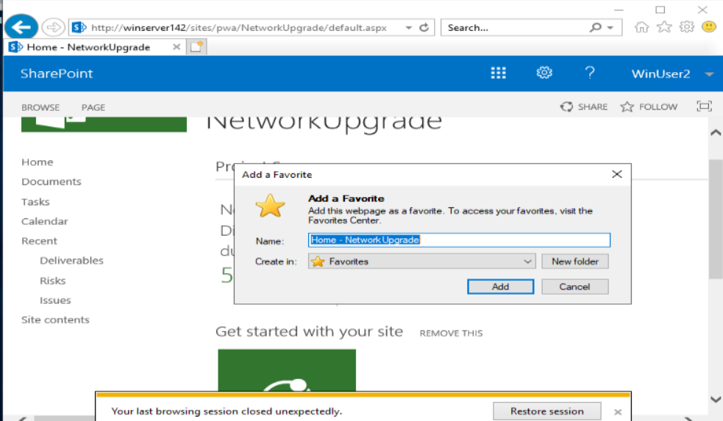

Windows Summary: Project Server 2019 was successfully configured on WindowsServer142 with SharePoint integration. A new “Network Upgrade” project was created using the SharePoint Task List method. WinUser1 and WinUser2 were assigned individual tasks with deadlines and verified for project site access through the SharePoint web console. The setup provided centralized task management aligned with enterprise project standards.

# Linux

Linux Objective : To install and configure OpenProject on a Debian-based Linux system for collaborative project management of a simulated Network Upgrade. Tasks include PostgreSQL integration, project creation, user account management, task assignment with deadlines, and verification of role-based web access.

Research and choose between Open Project or dotProject project

management software.

### Install all prerequisite software for the package chosen

Follow instructions from the website

<https://www.openproject.org/docs/installation-and-operations/installation/packaged/#debian-12>

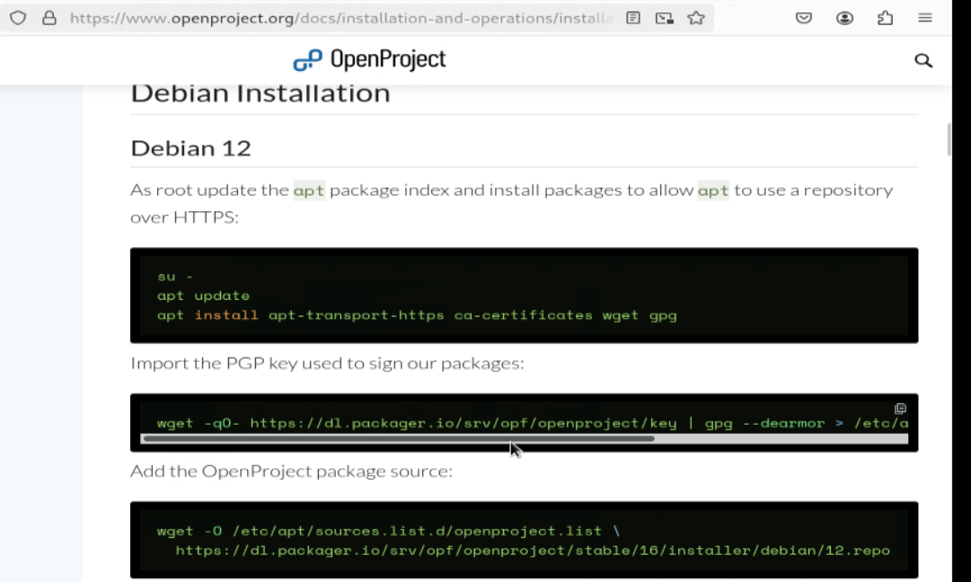

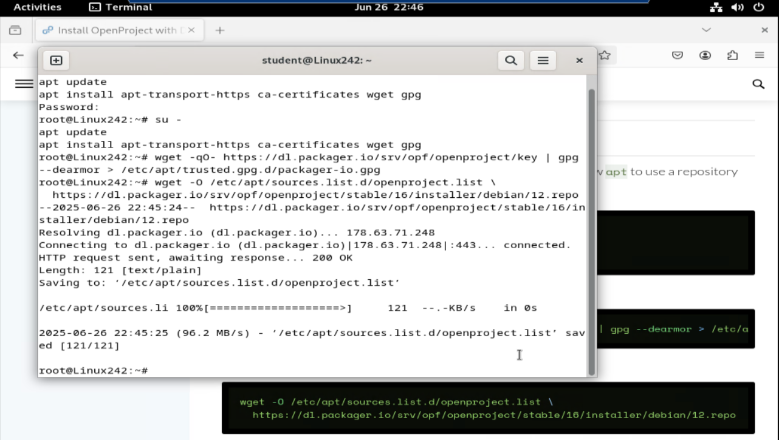

### Install and configure your chosen Project software platform

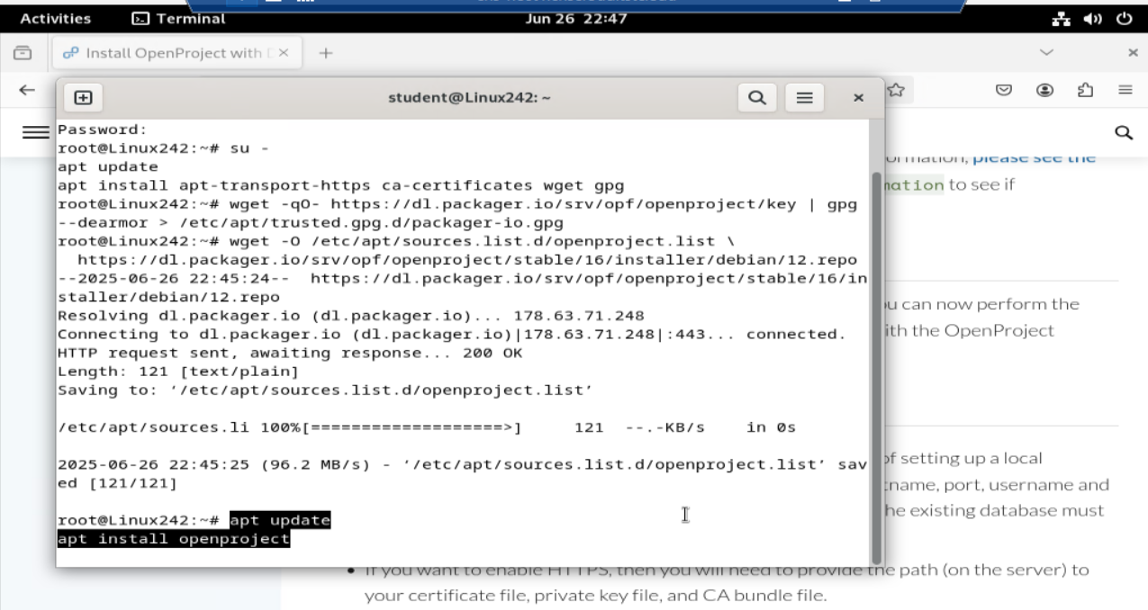

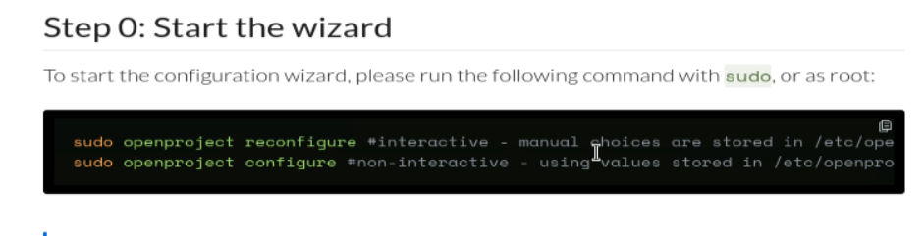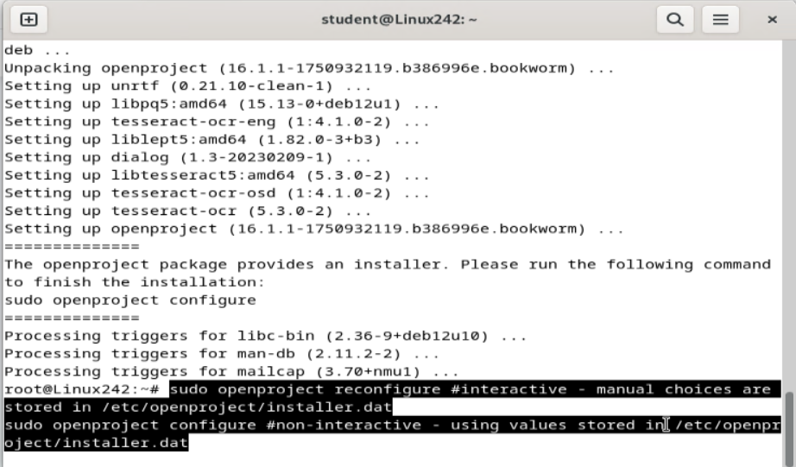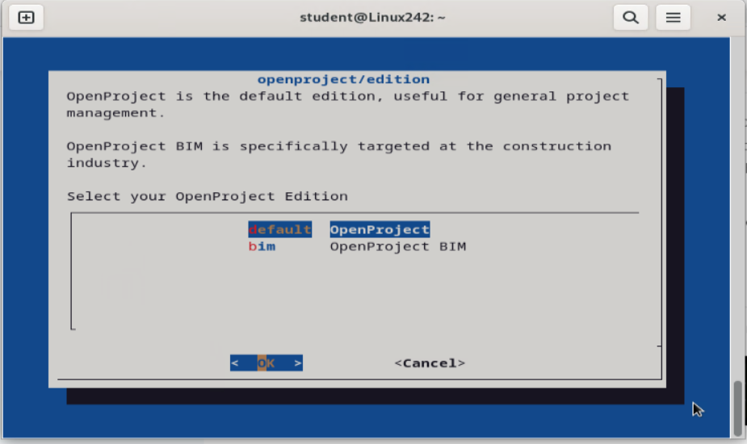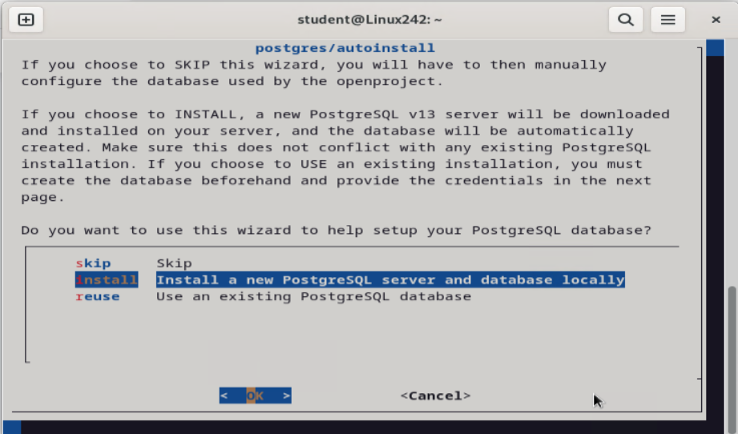

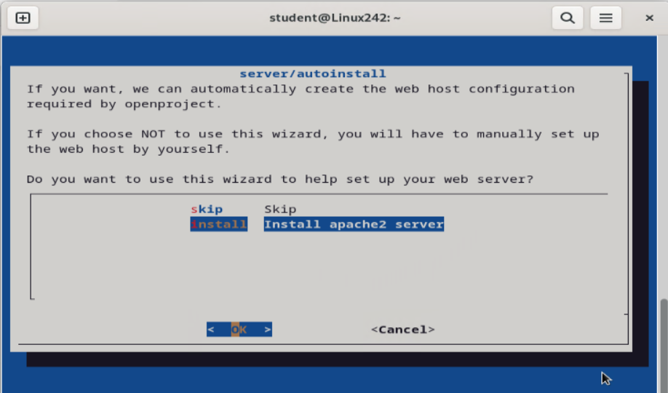

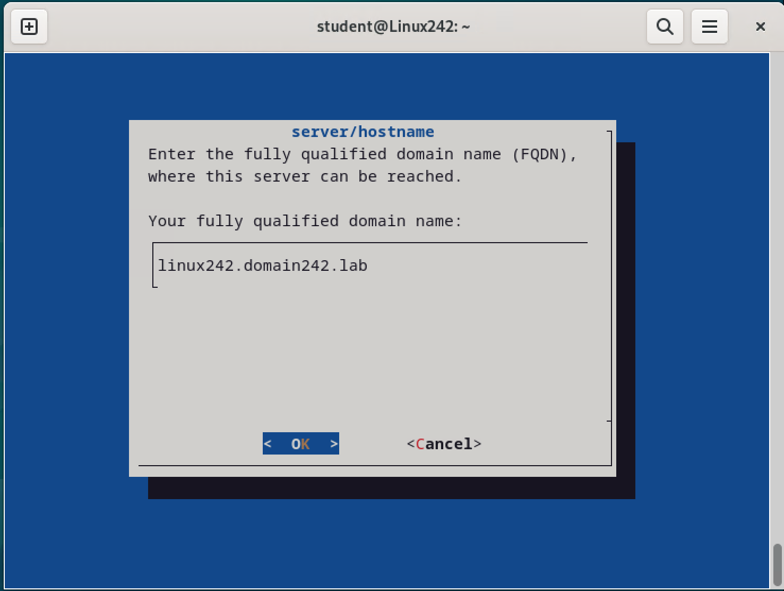

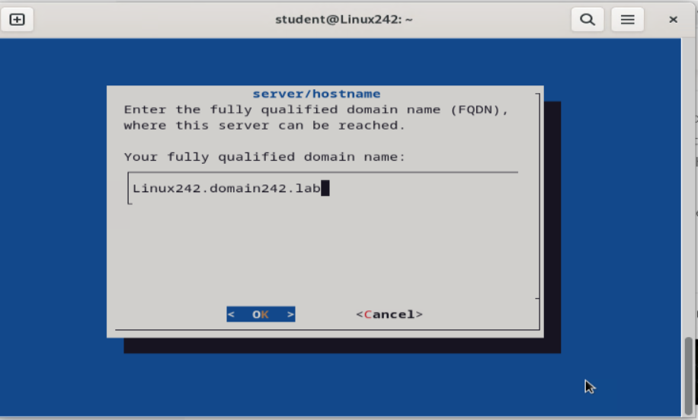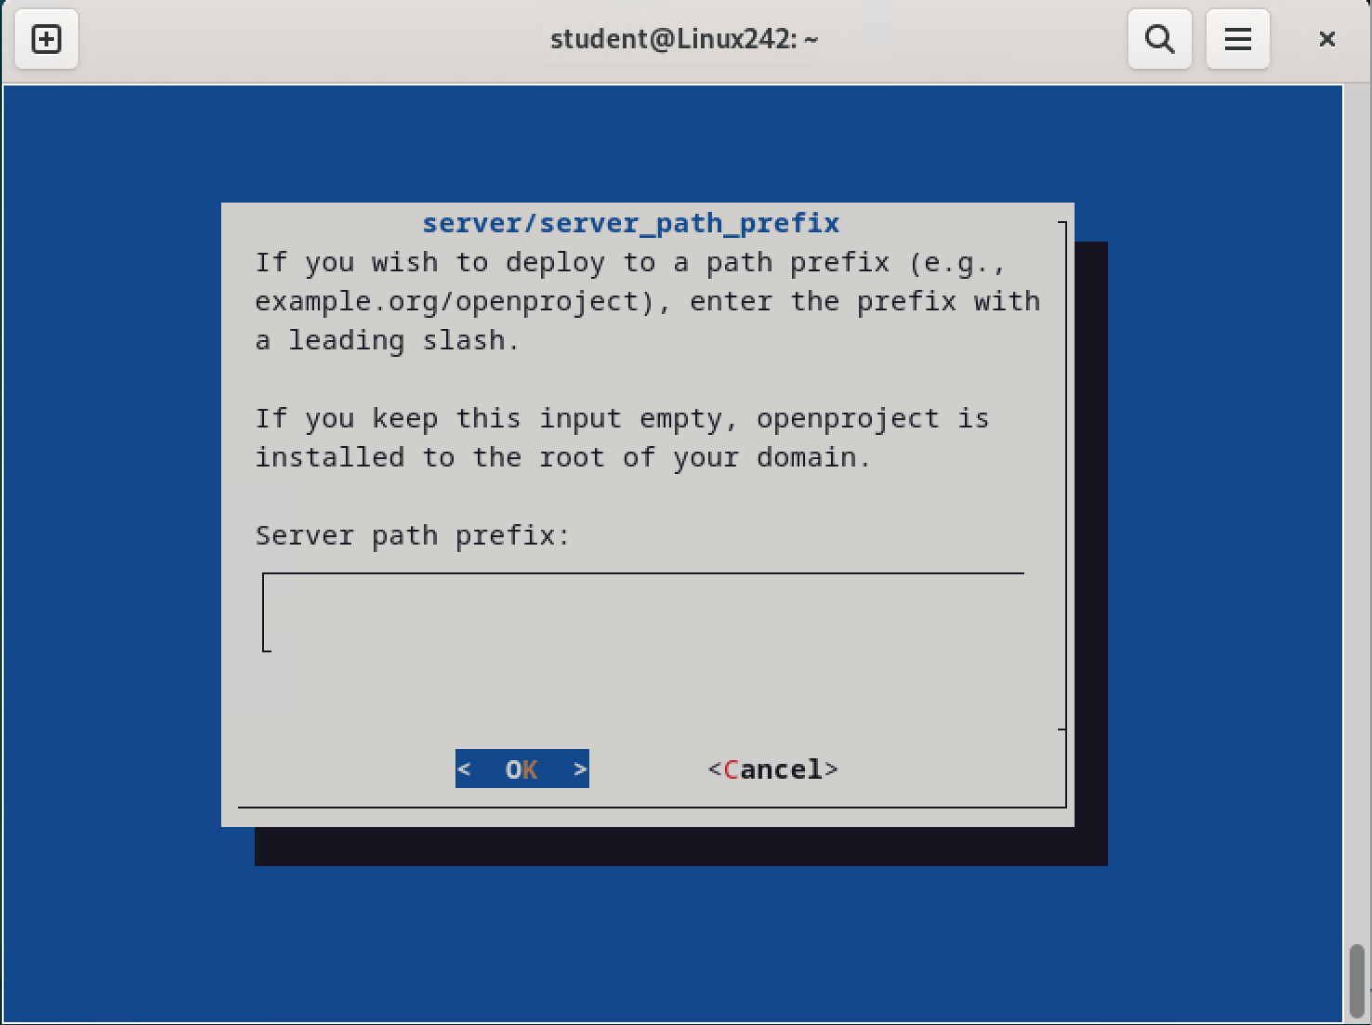

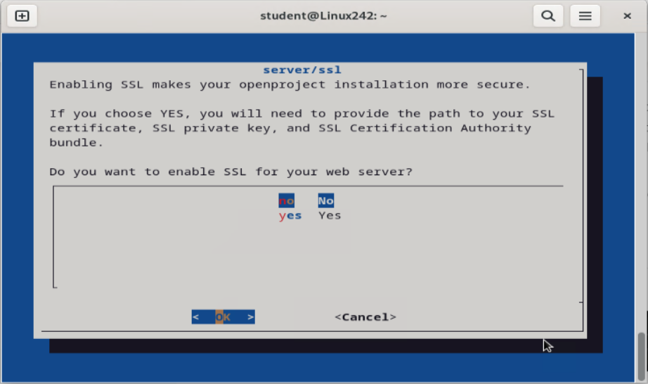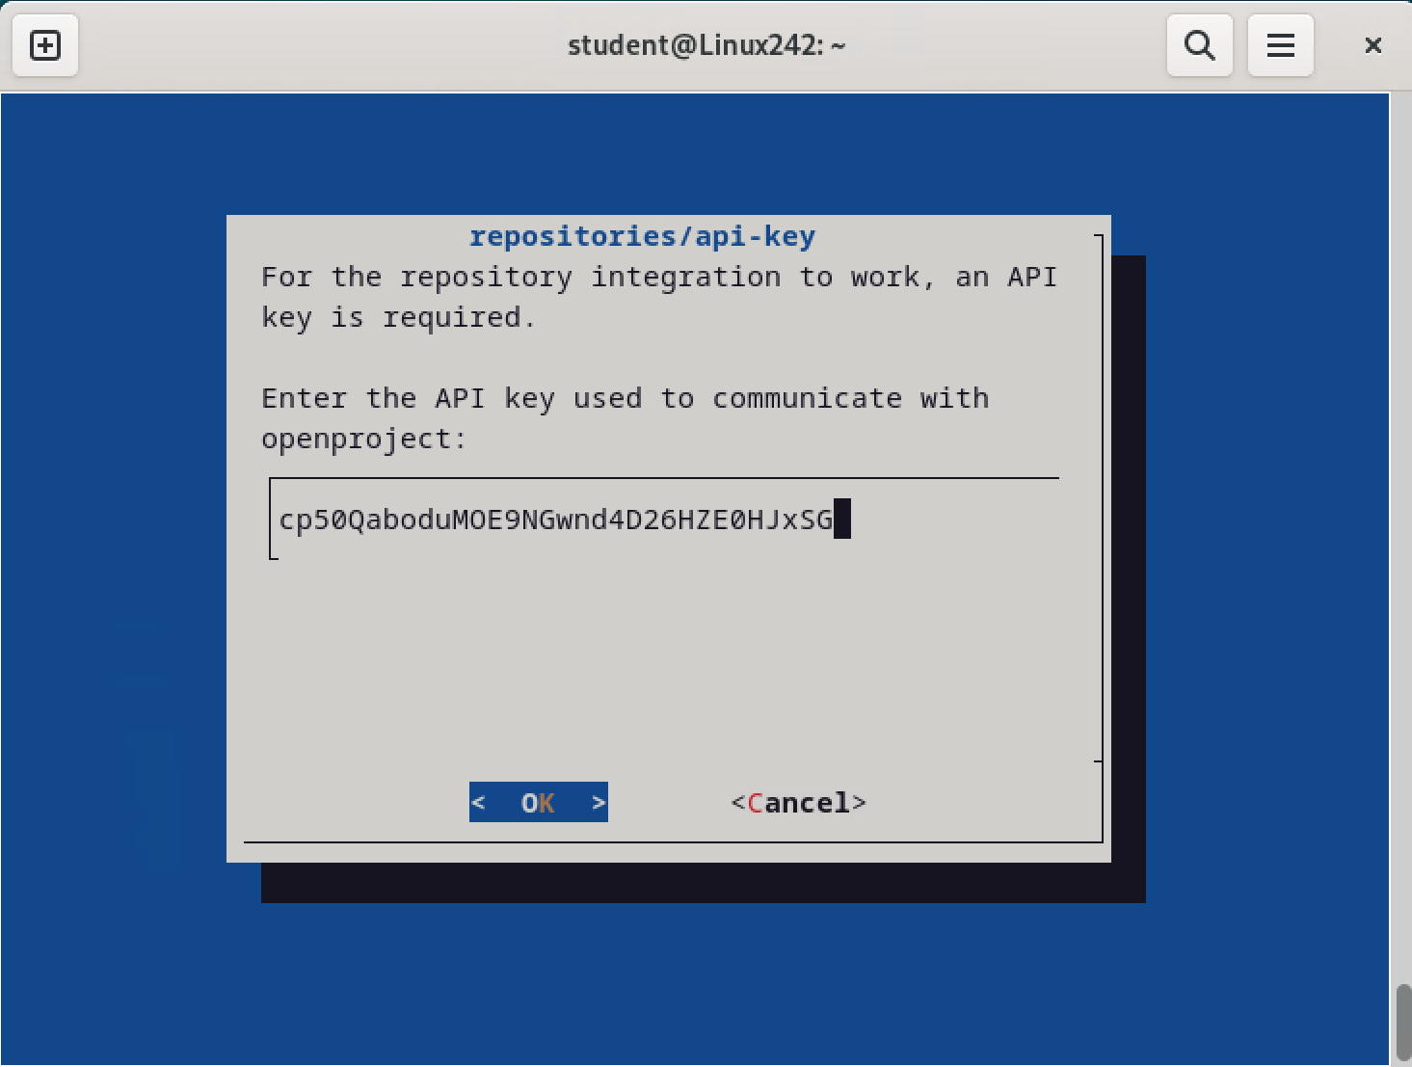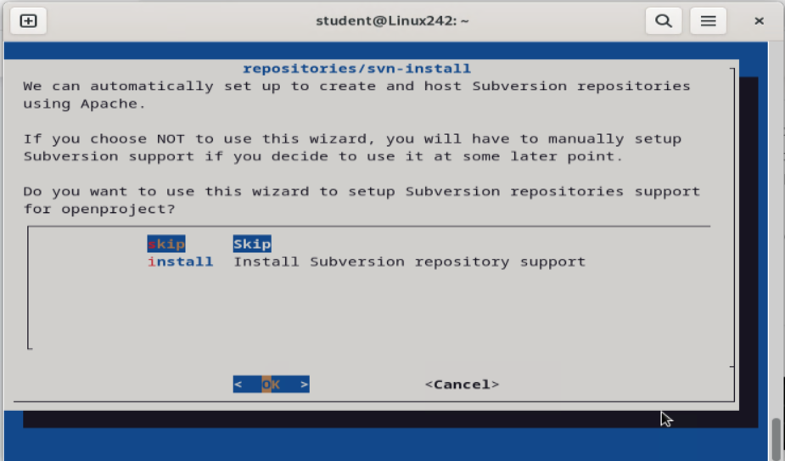

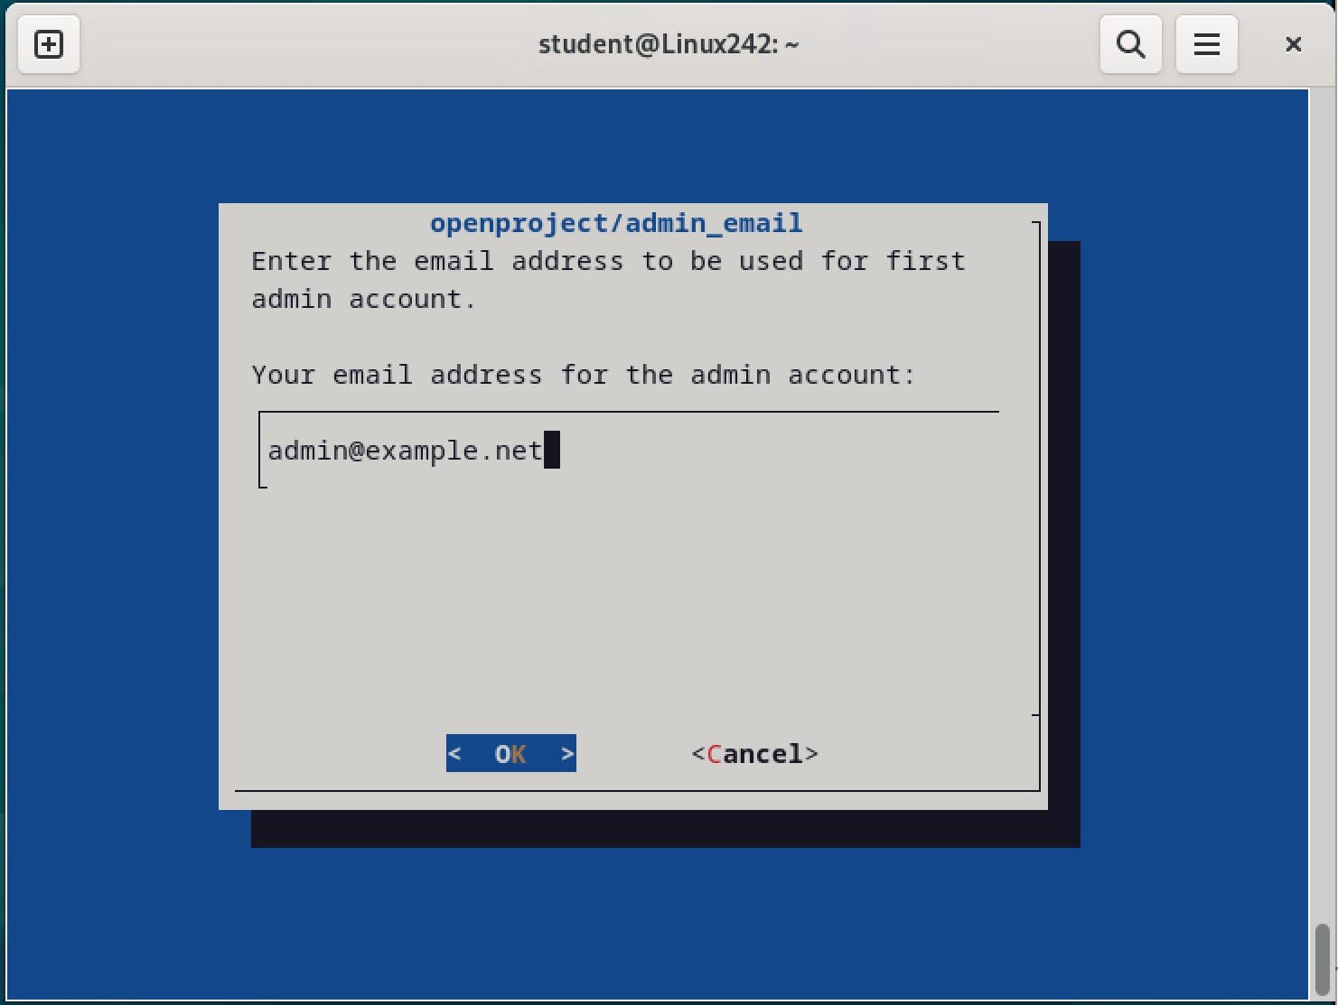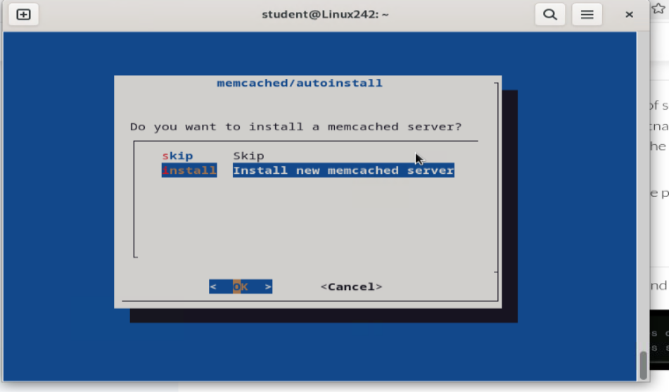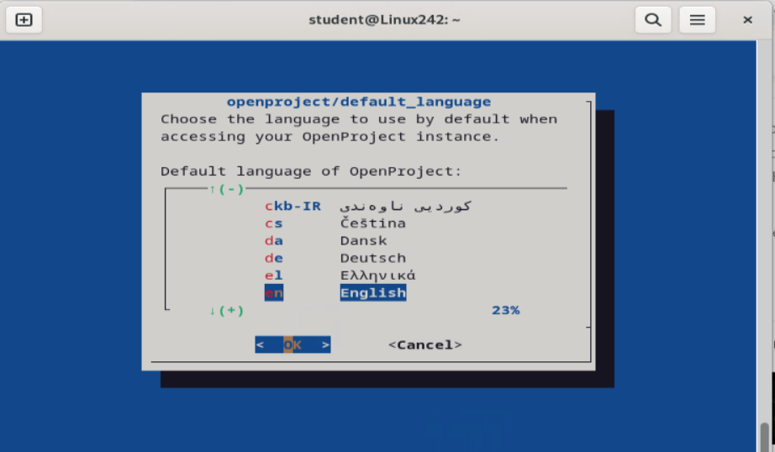

### Configure a web-based ‘Network Upgrade’ project in your chosen project management Solution

**enter** [**http://linux242.domain242.lab**](http://linux242.domain242.lab)

**Username: Admin**

**Password: Admin**

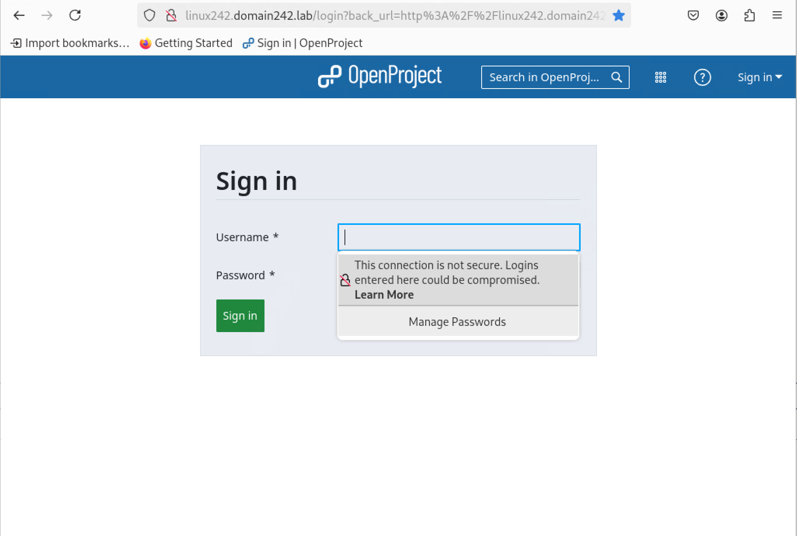

Change Password to **Password12**

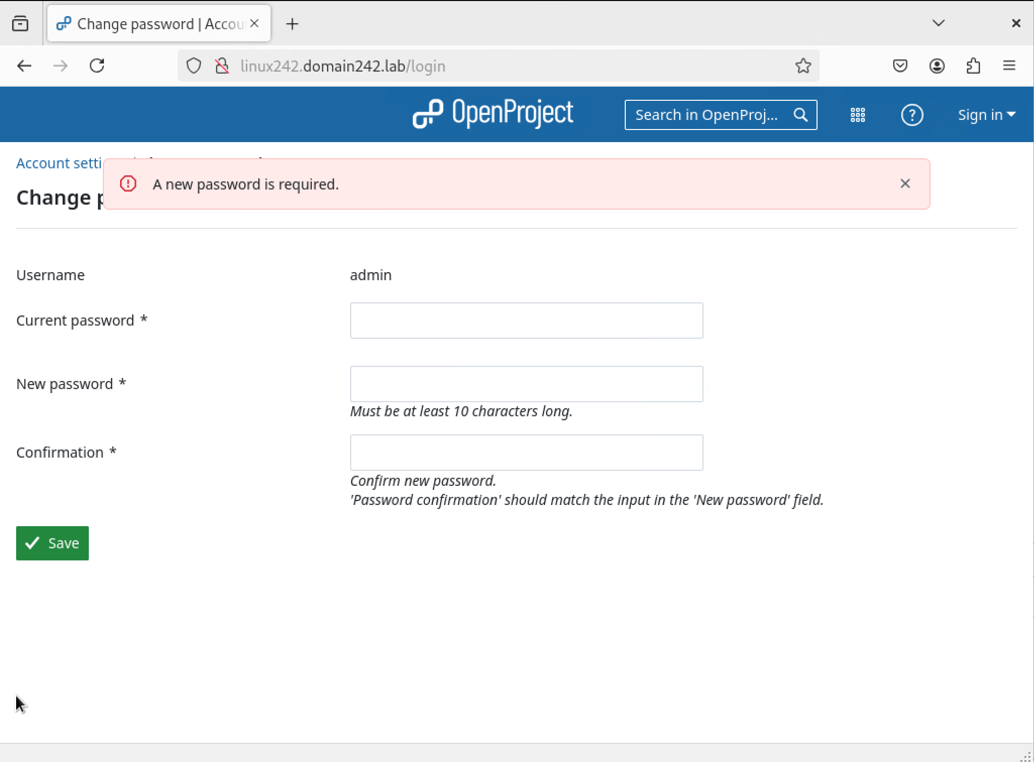

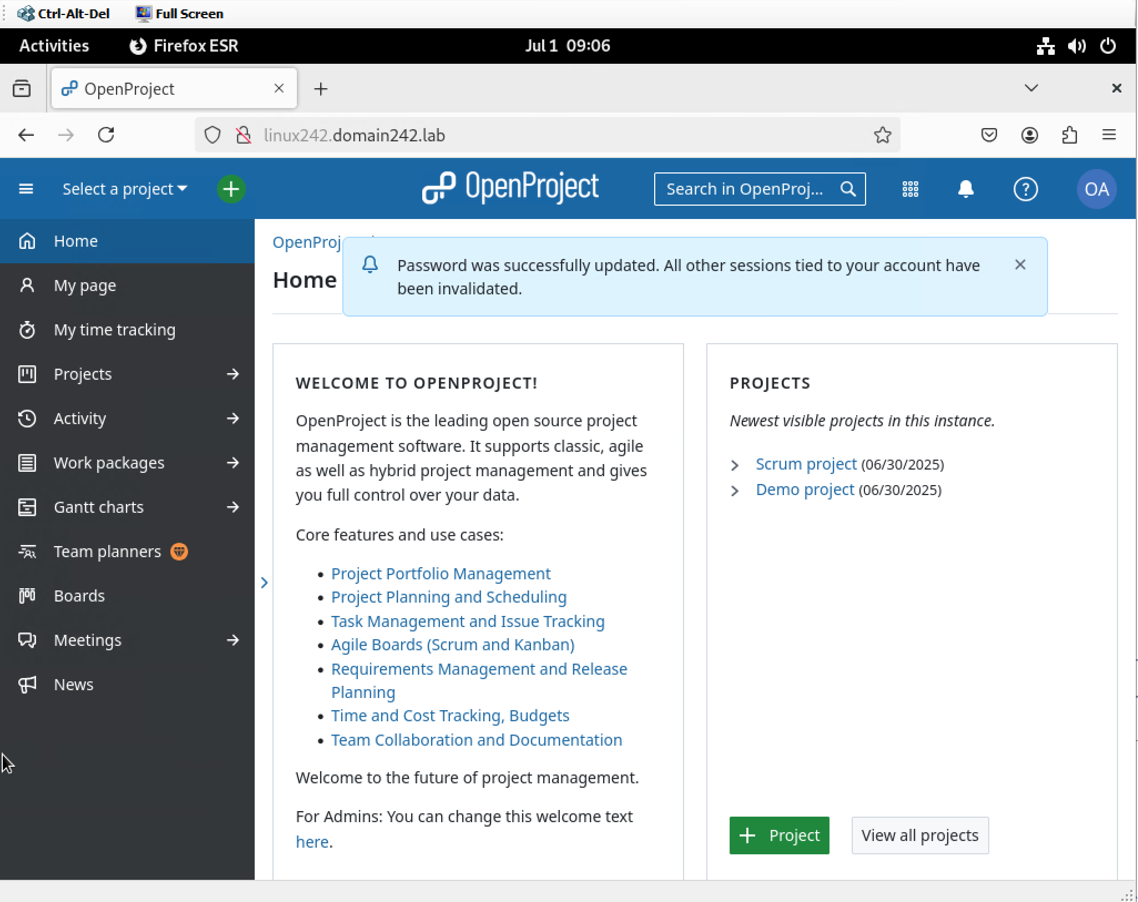

Select New Project

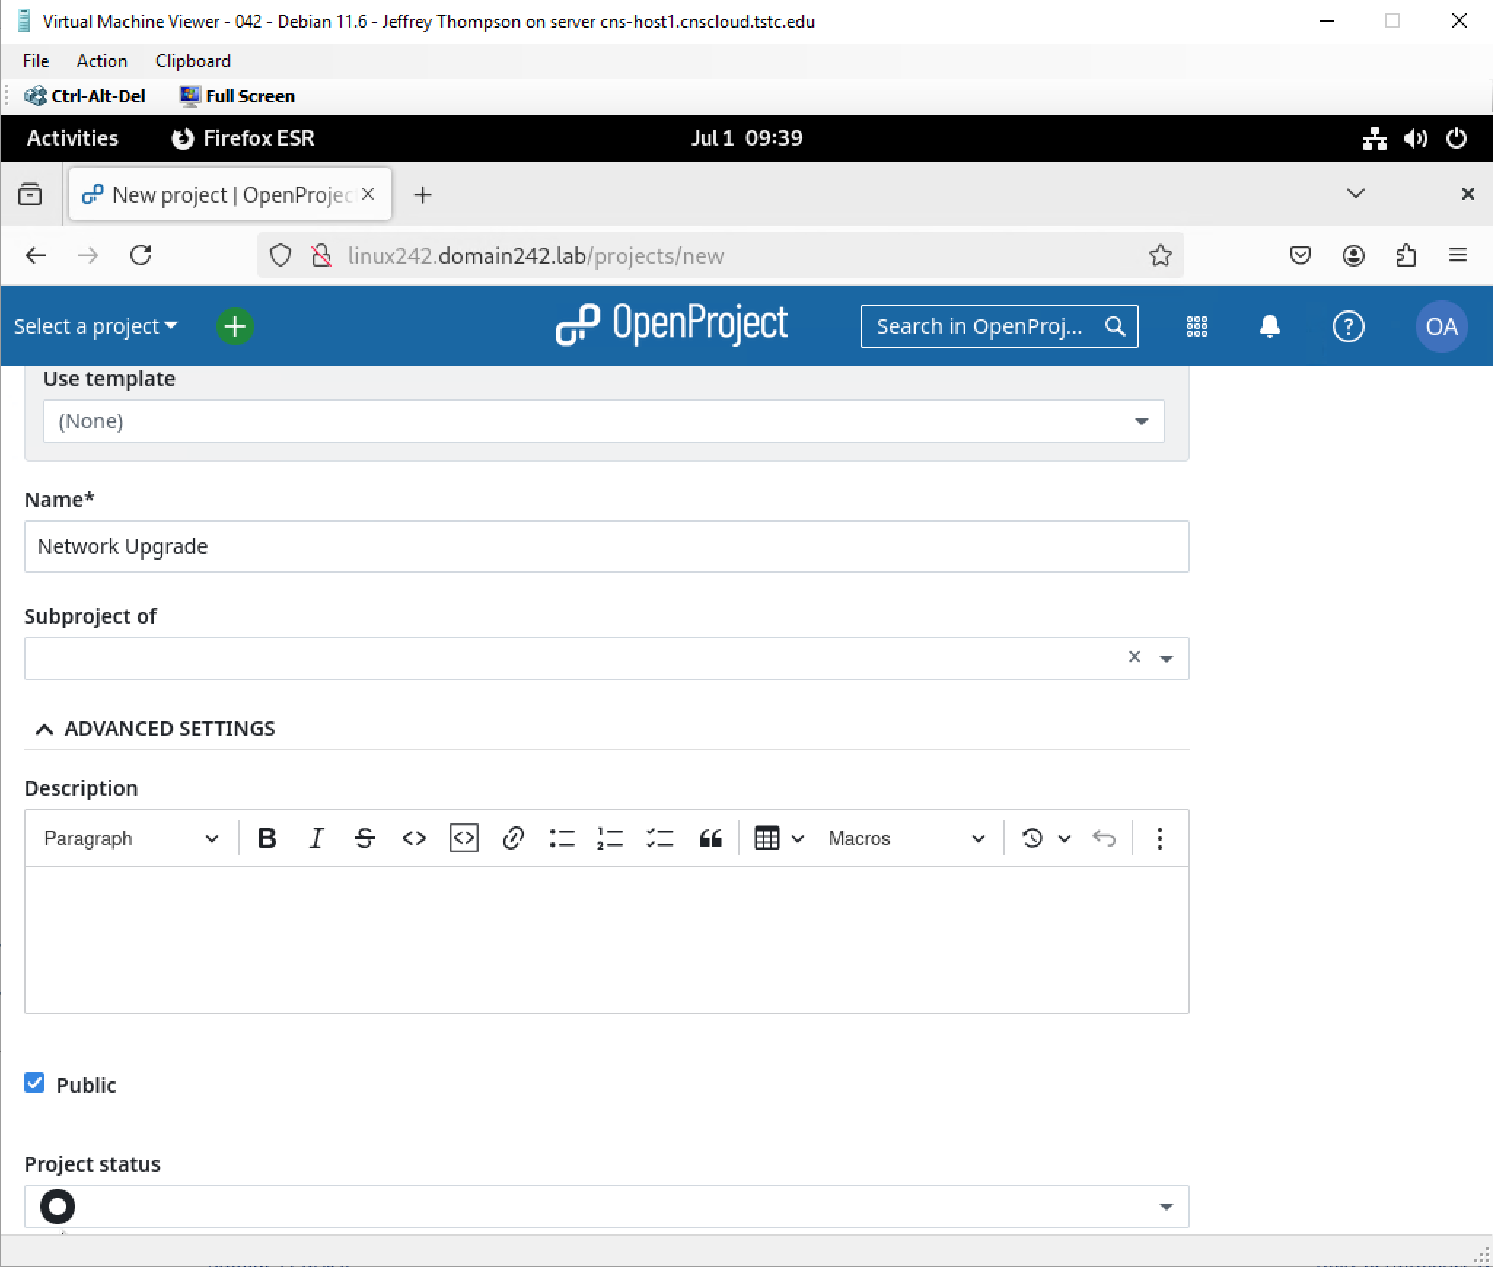

### Create users named ‘LinuxUser1’ and ‘LinuxUser2’ in your chosen project management solution and set their passwords to ‘Password2’

(make sure they are not required to enable their account via email)

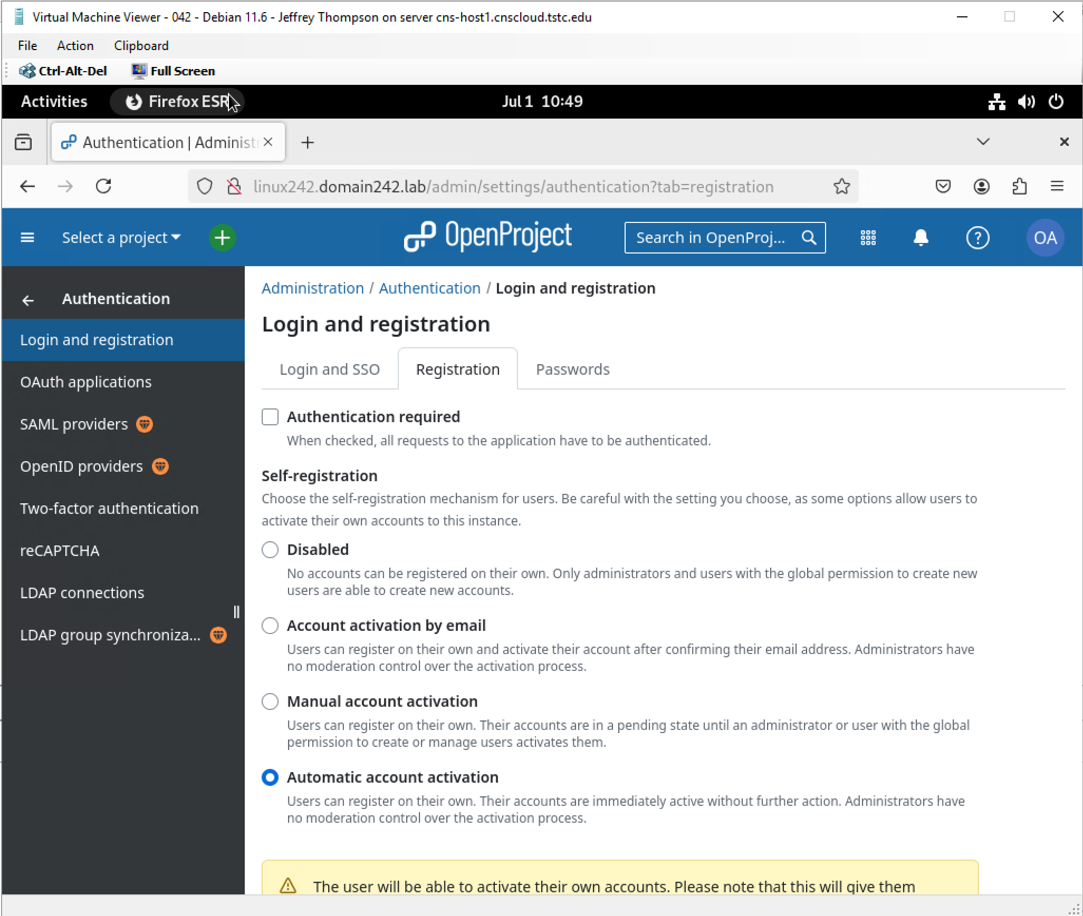

Scroll down to Administration on the home page > Users

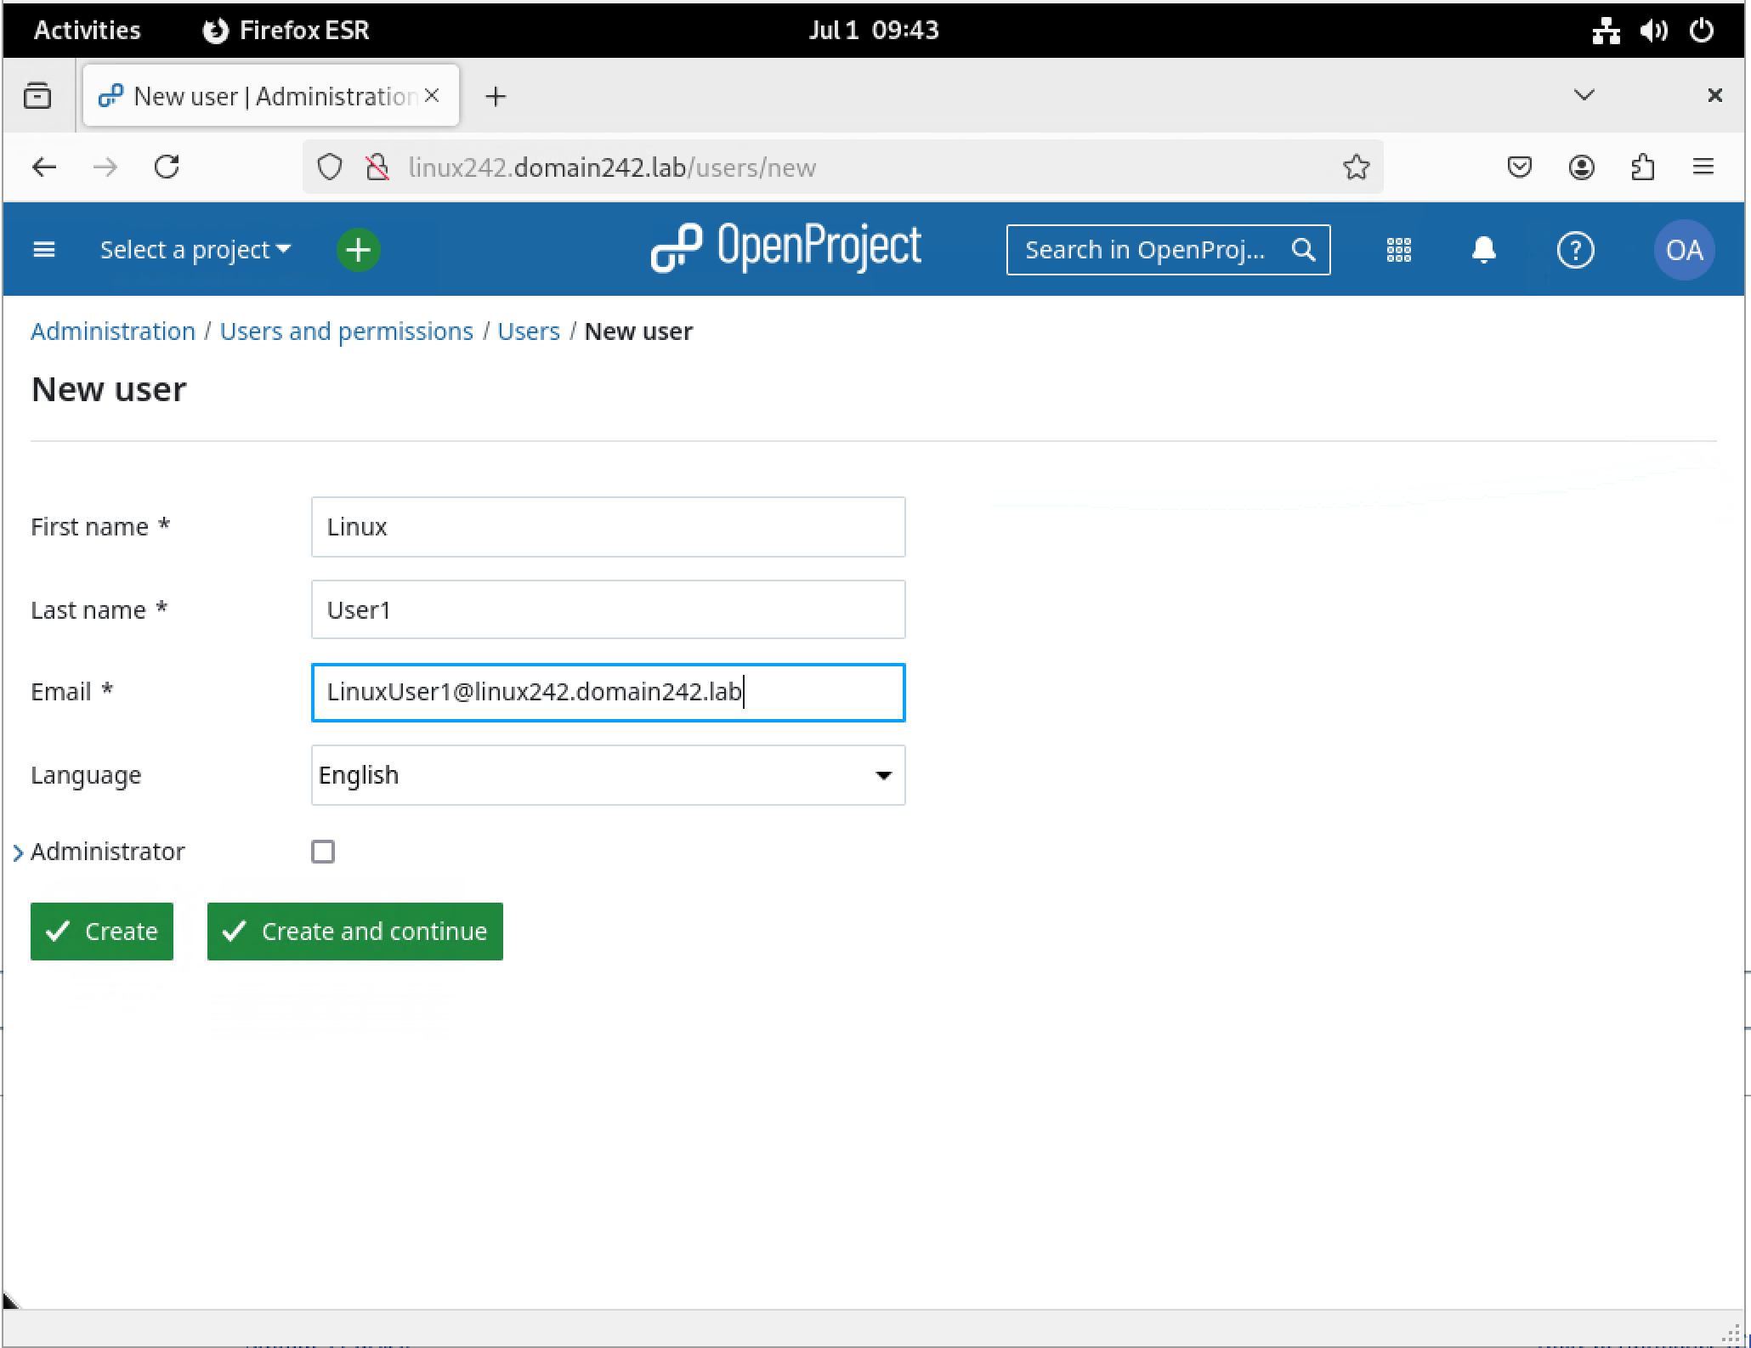

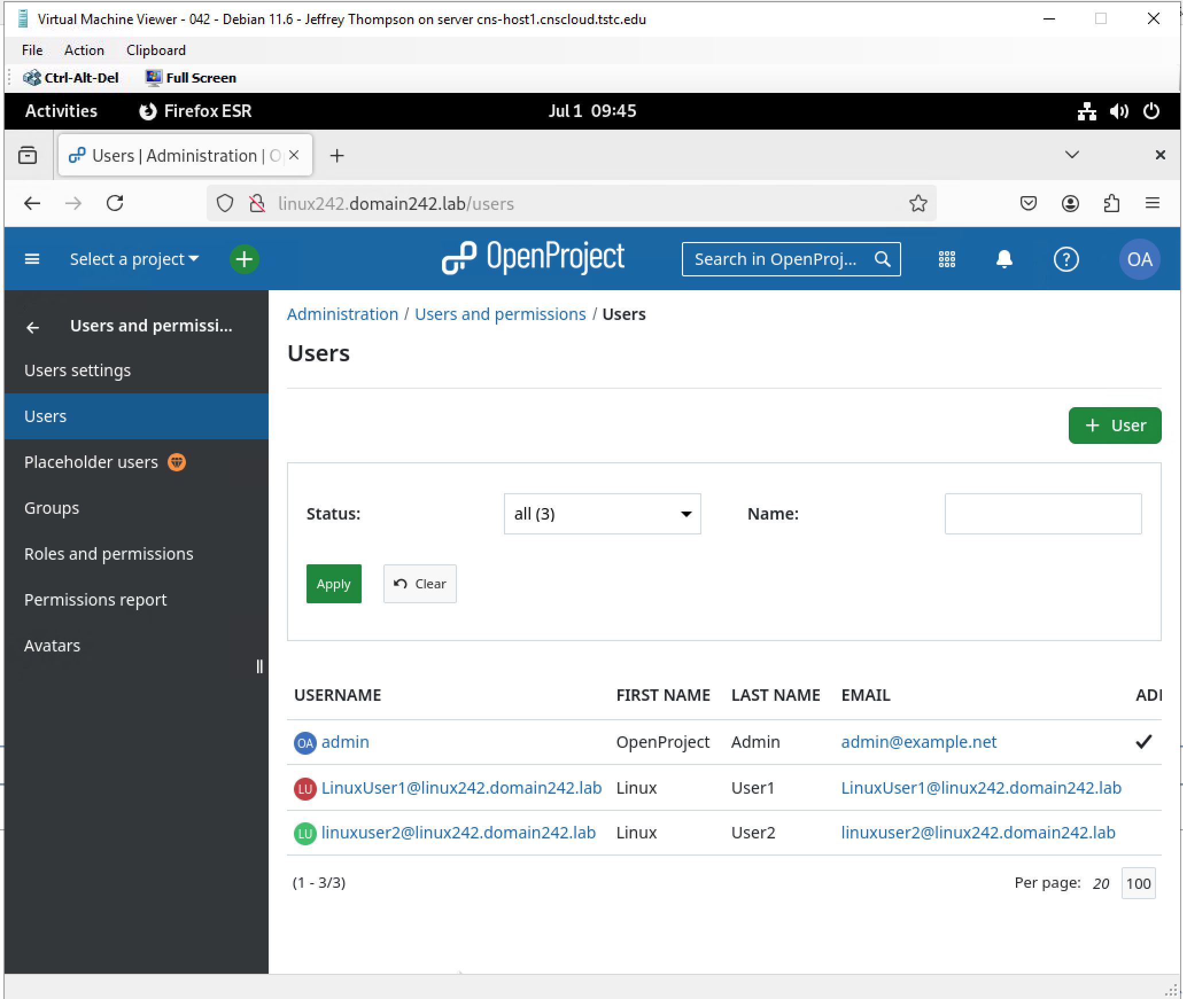

Change the password rule to 8 characters. Administration> Authentication> Login and Registration> Passwords Tab

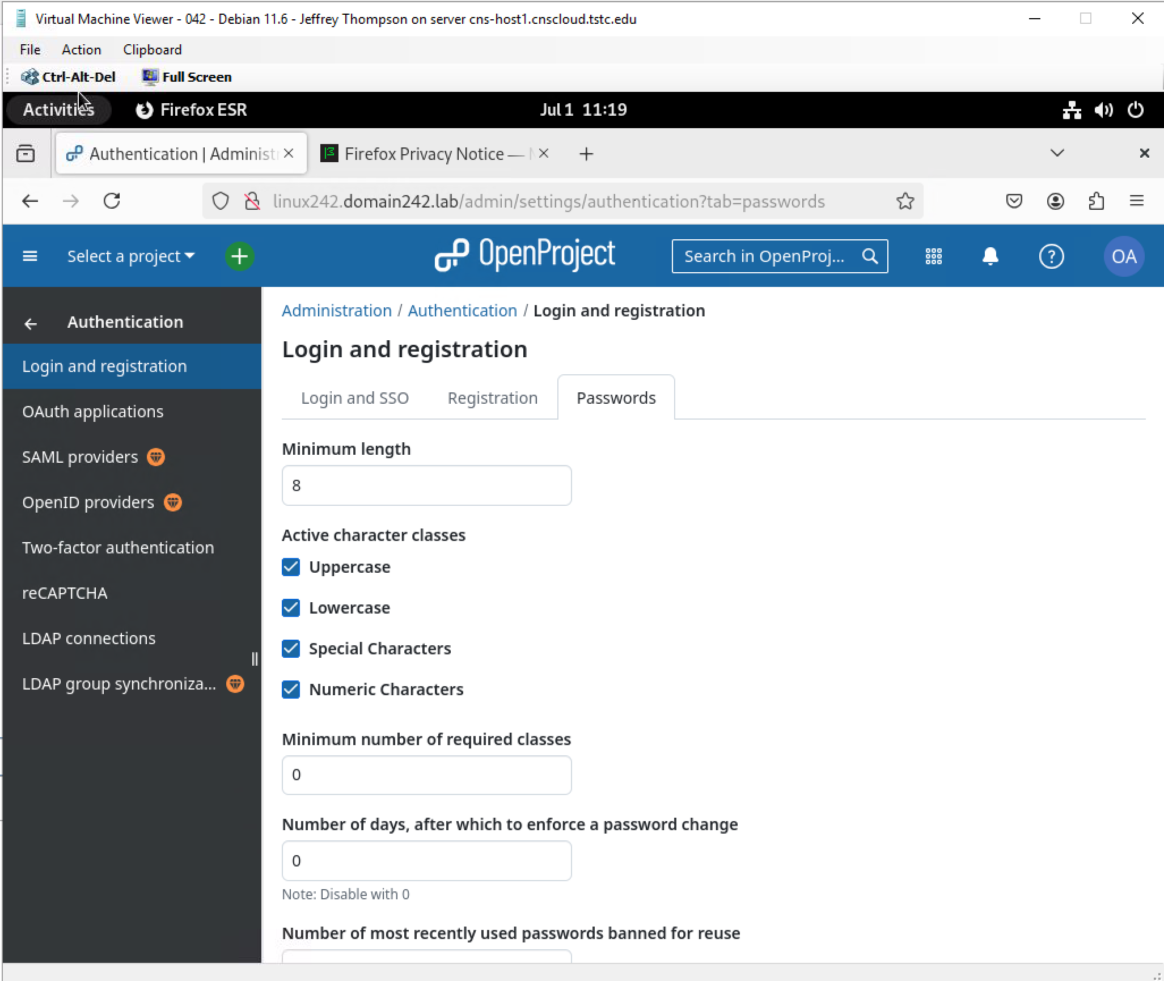

Assign Passwords to each. **Password2**

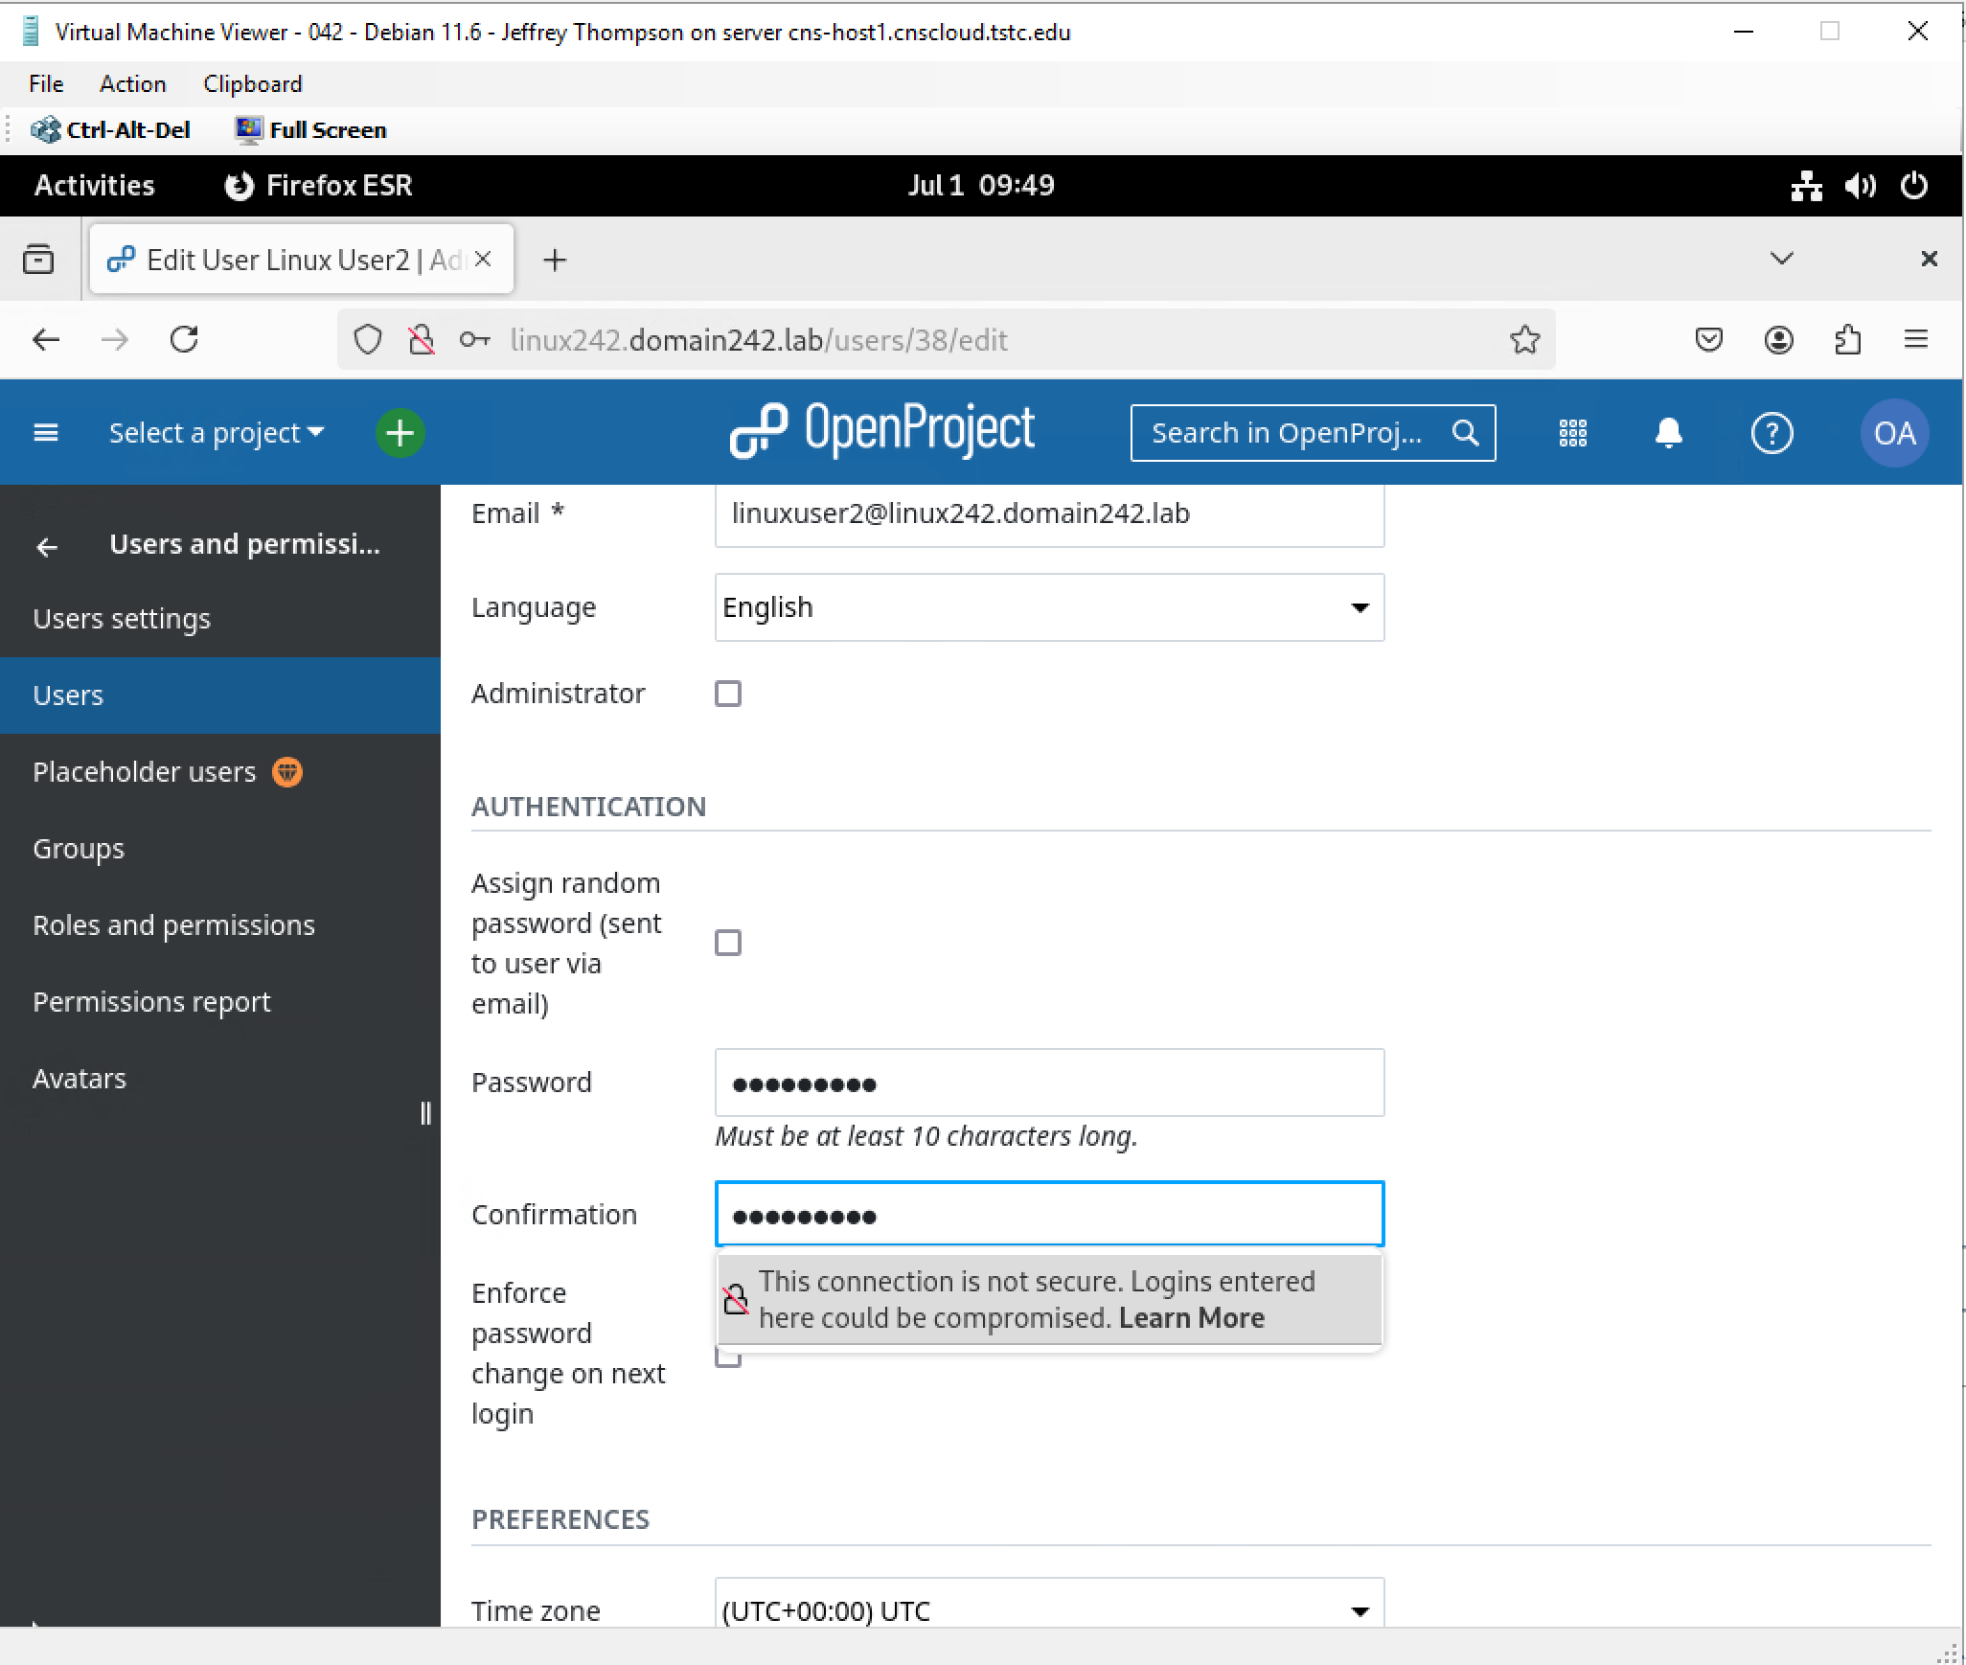

### Share your Project site with your LinuxUsers

### Assign ‘LinuxUser1’ and ‘LinuxUser2’ to work on the project.

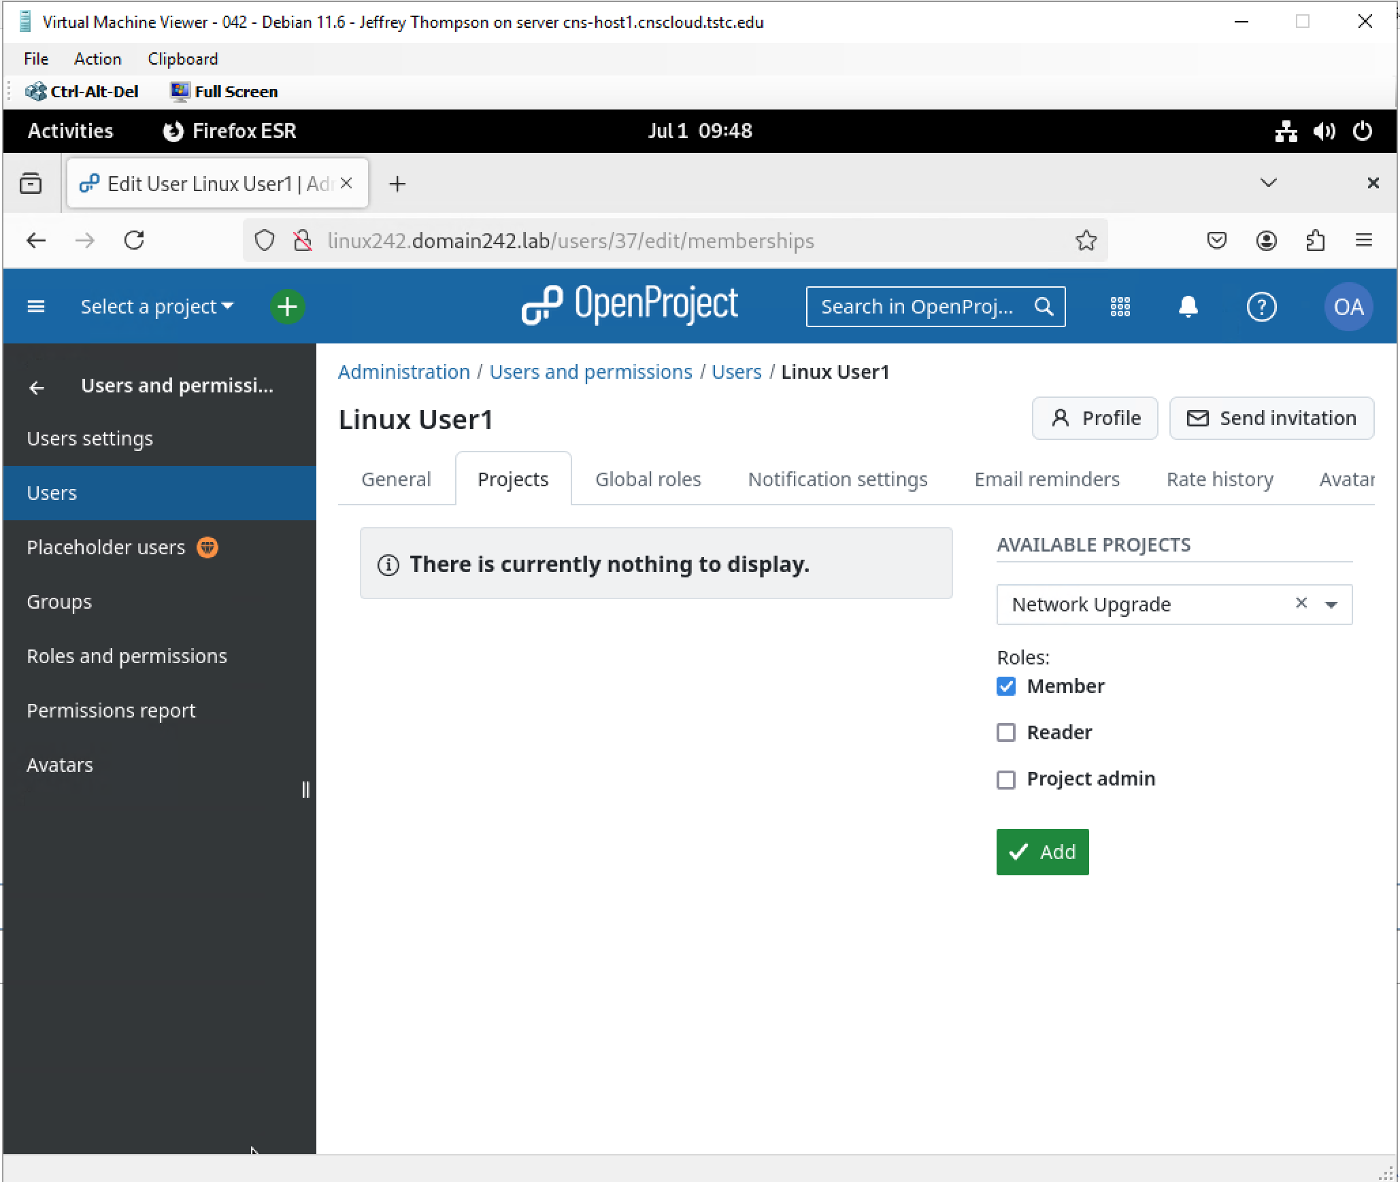

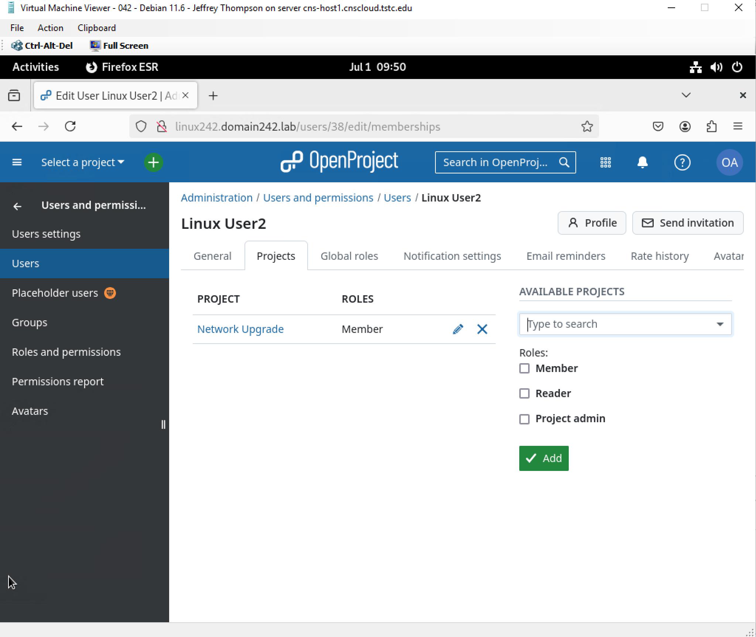

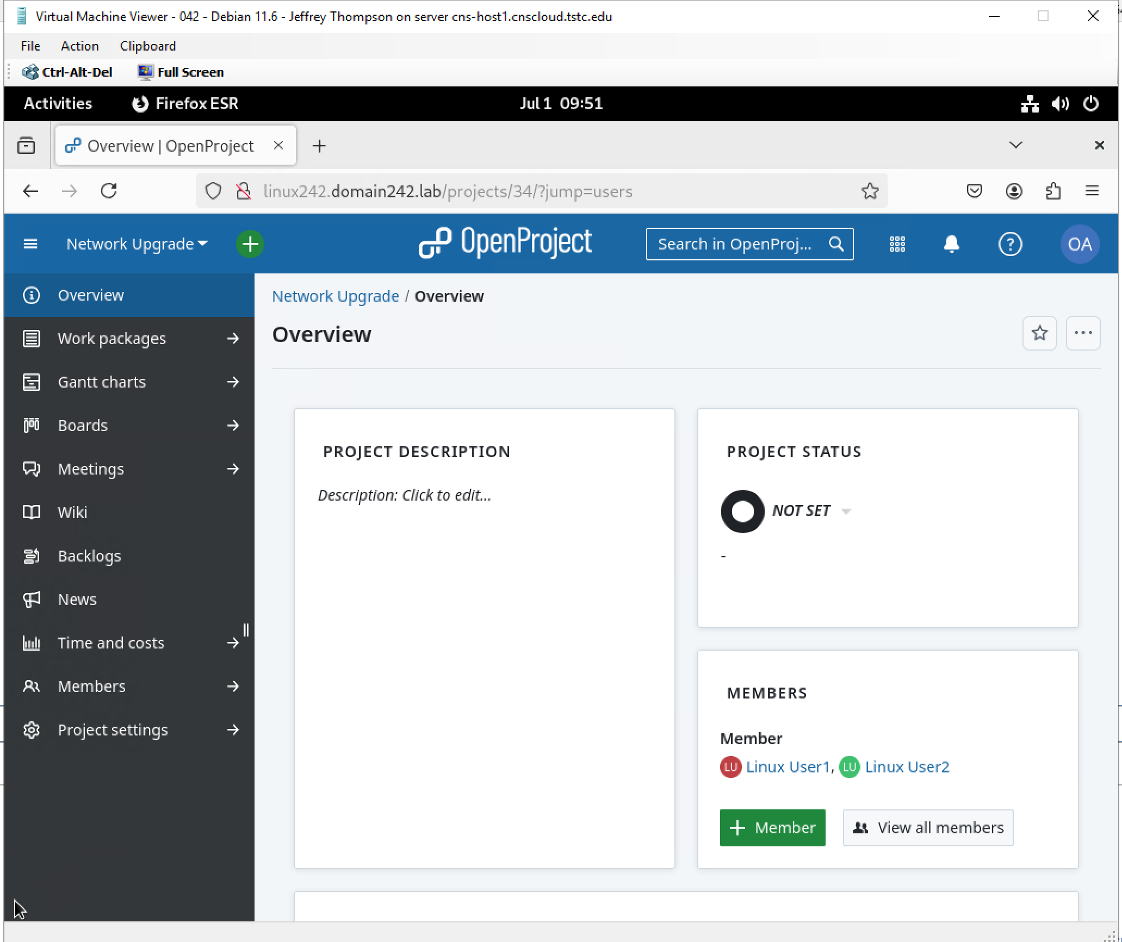

### In your ‘Network Upgrade’ project, create and assign at least one task with a deadline for LinuxUser1

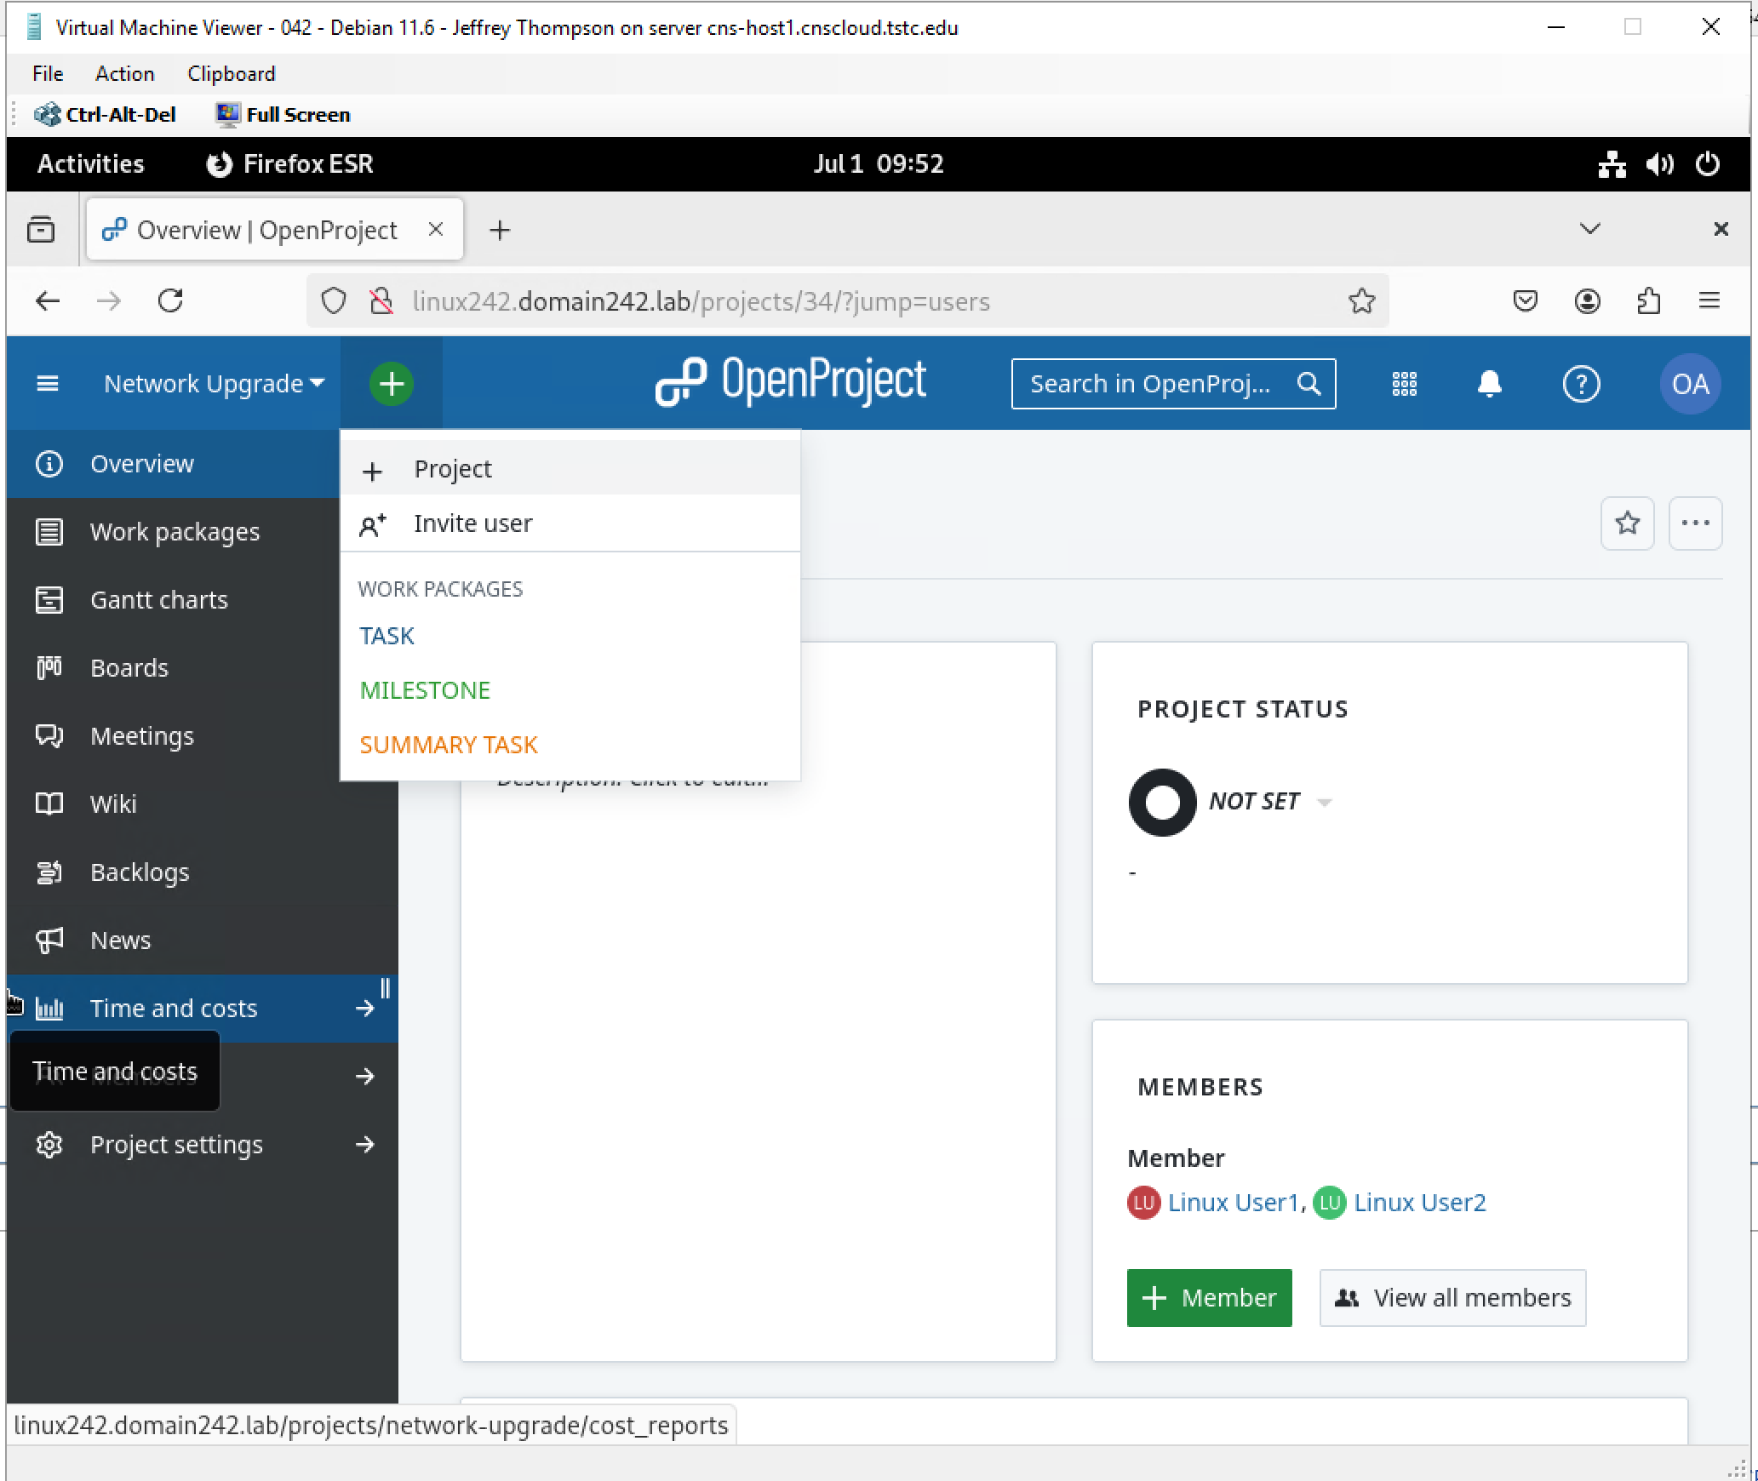

### In your ‘Network Upgrade’ project, create and assign at least one task with a deadline for LinuxUser2

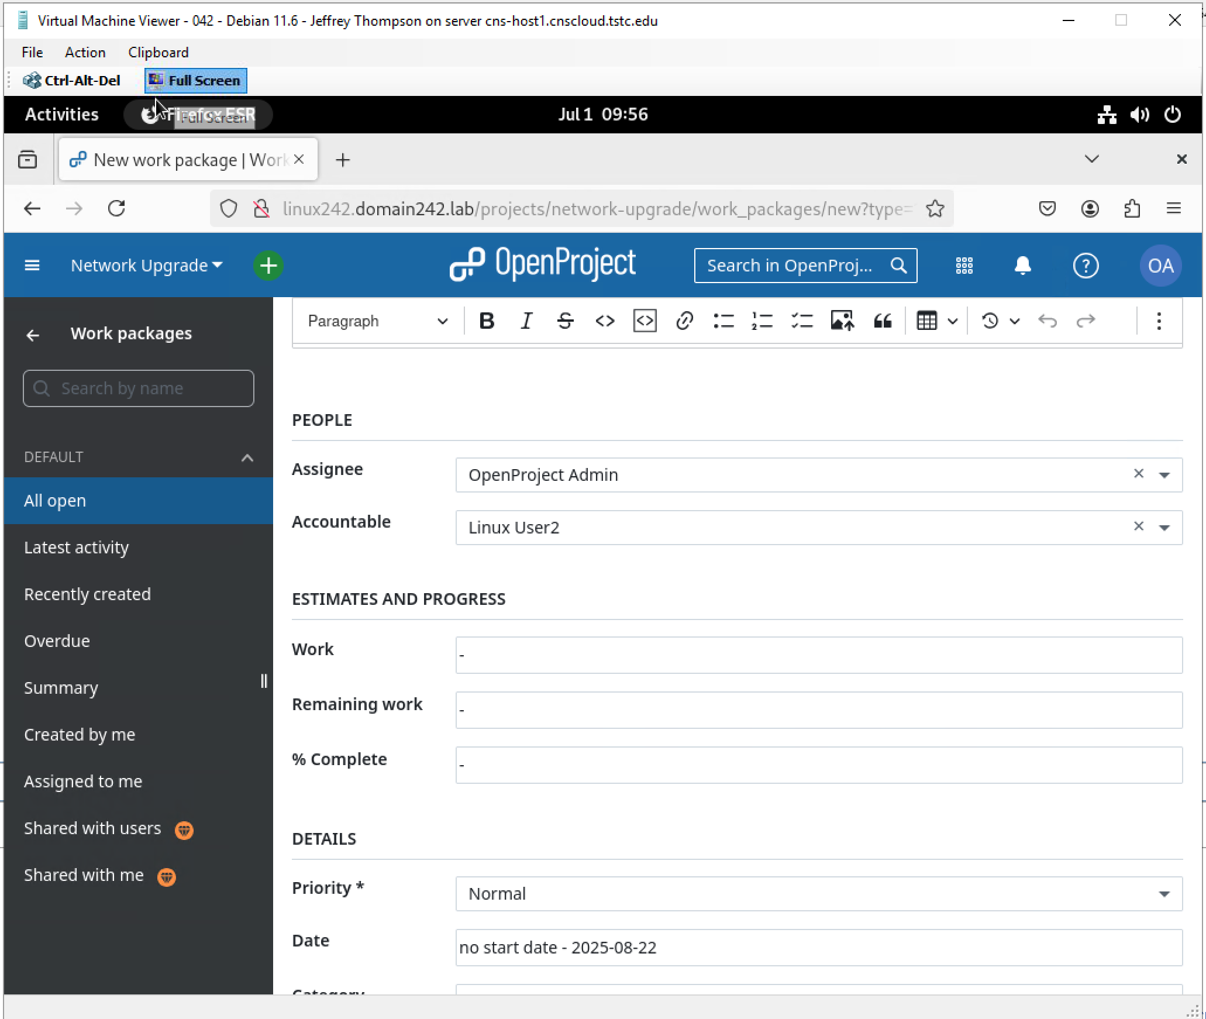

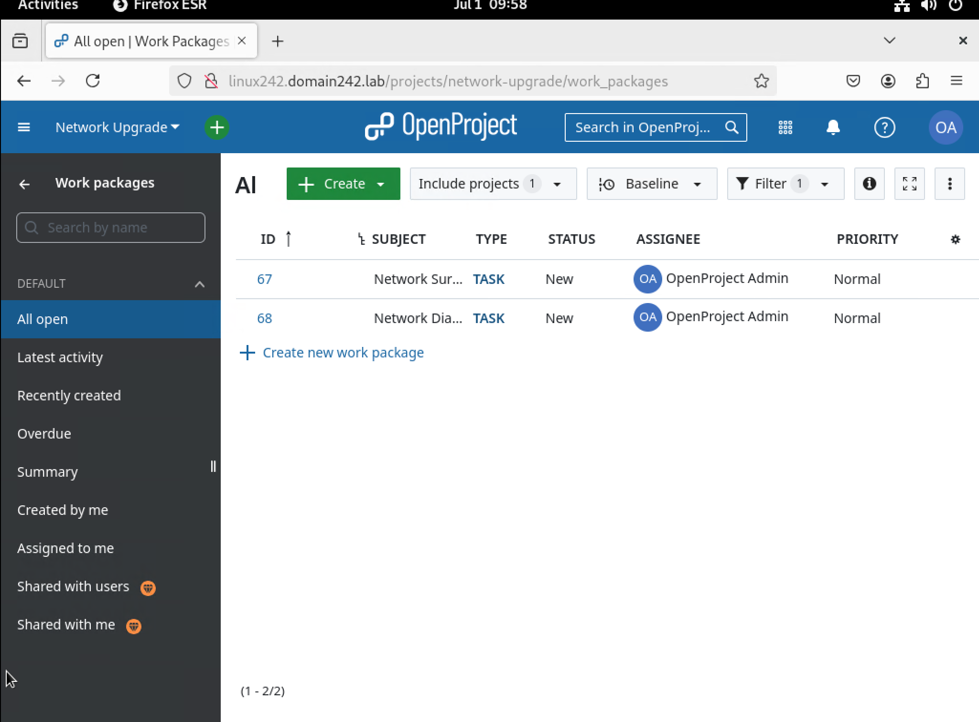

Log on to your Linux virtual machine as LinuxUser1 and verify ‘LinuxUser1’ has access to

the Project and assigned tasks using your installed Project software solution * / **

a. Bookmark the logon page for your installed Project software solution for

LinuxUser1

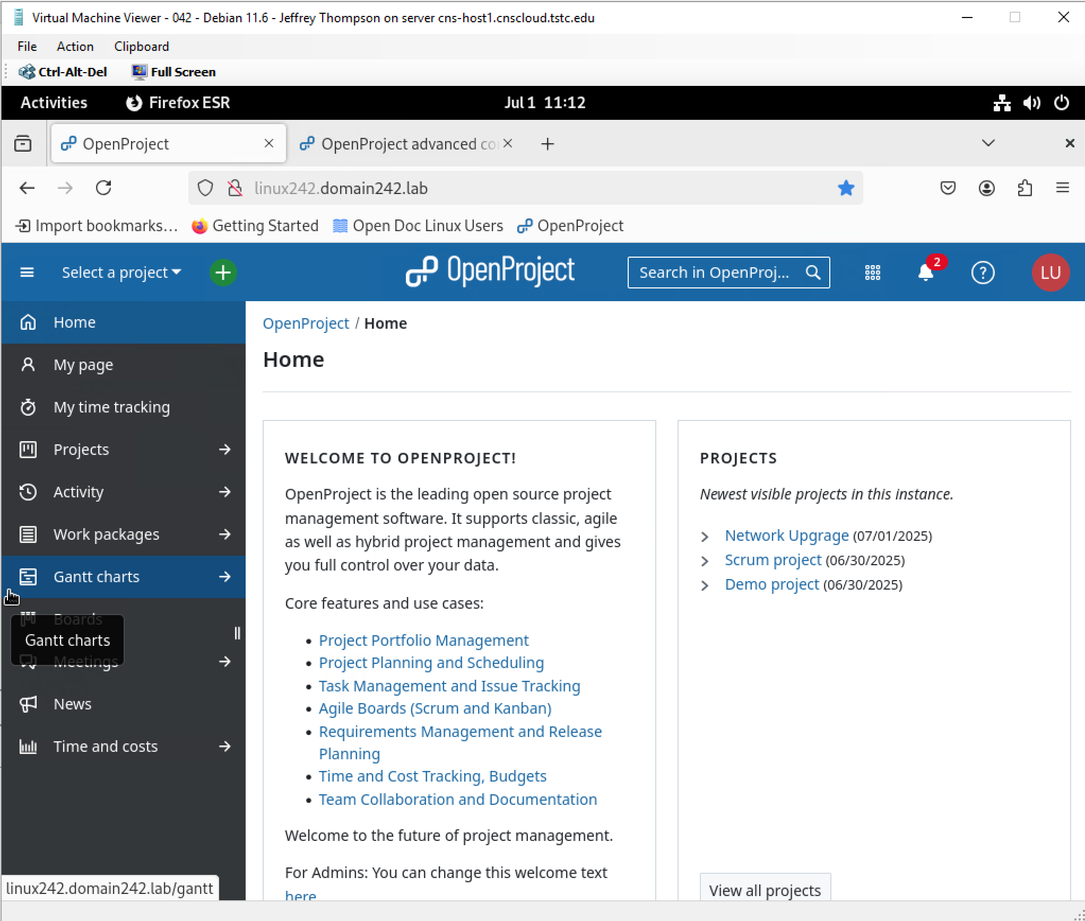

Log on to your Linux virtual machine as LinuxUser2 and verify ‘LinuxUser2’ has access to

the Project and assigned tasks using your installed Project software solution * / **

a. Bookmark the logon page for your installed Project software solution for

LinuxUser2

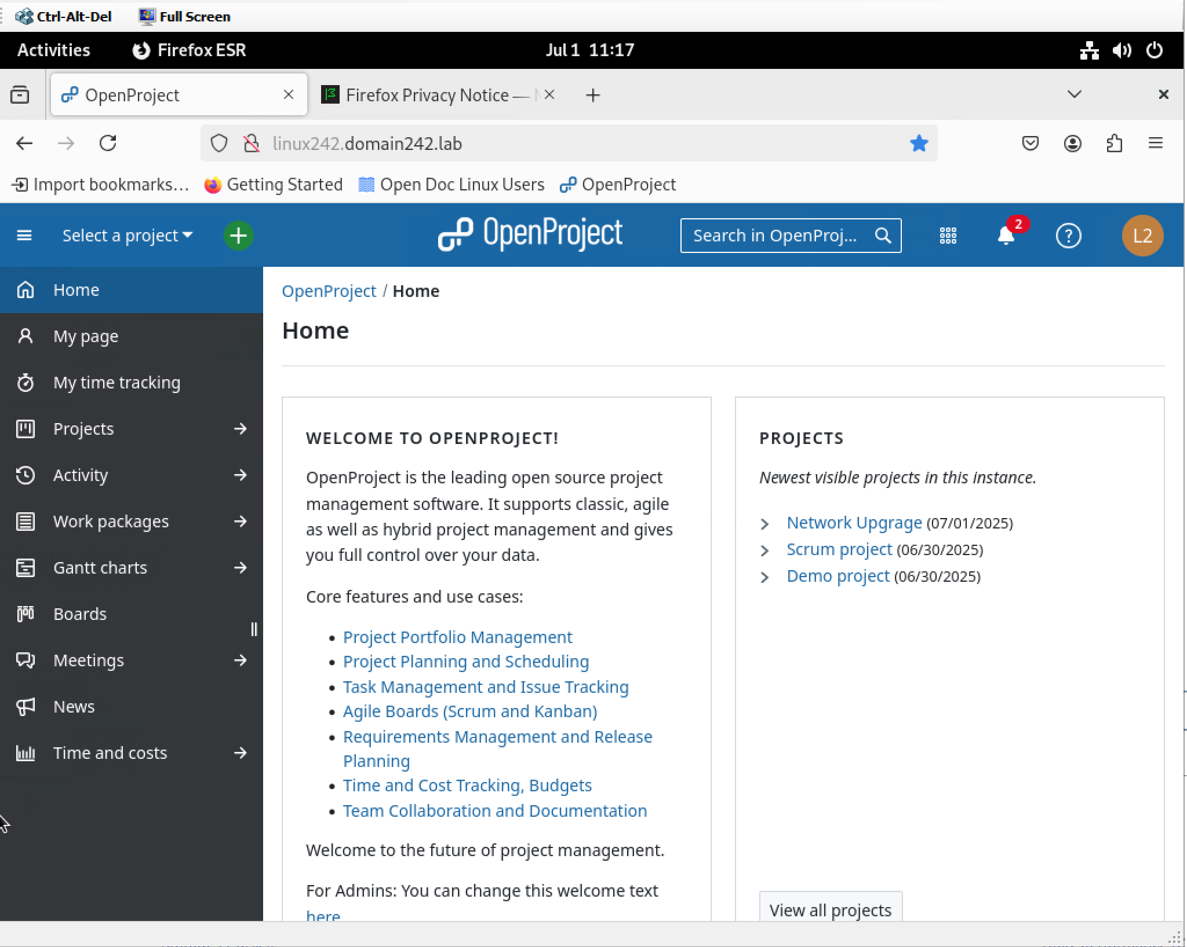

### REBOOT YOUR SERVER and repeat the previous two steps of verifying LinuxUser Access

Linux Summary: OpenProject was successfully deployed on Linux242 with a PostgreSQL backend. LinuxUser1 and LinuxUser2 were created, assigned project tasks, and verified for login and task visibility. The platform enabled browser-based collaboration and task tracking through a centralized web interface, meeting all module objectives for the Linux-based solution.